Formative / Summative Evaluation
Of The Gallery Guide Program
At The Frye Art Museum
New Directions Project
Spring 2012

Research Team: Mark Rosen, Rose Paquet Kinsley, Peder Nelson

Report reviewed by Nick Visscher, Kris Morrissey and Kathryn Owen

Funded by

New Directions Partner Institutions

Executive Summary

This report describes the findings of an evaluation of the Gallery Guide program at the Frye Art Museum in Seattle, Washington. It aimed to determine if and how 6 identified public tour goals are being met and examined how visitors are generally engaging during public tours at the museum.

List of Key Findings:
- Overall all Gallery Guide goals were met to varying degrees.
- The majority of surveyed visitors reported they would feel comfortable leading a friend through the Frye after their tour experience.
- Gallery Guides provided a high number of informative statements (47%).
- Visitors appear more likely to make statements to the group as a whole than they are to converse with one another.
- A quarter of the tour participants were between the ages of 21 and 40, while nearly half of the participants were above the age of 51.
- The majority of surveyed visitors (68%) reported visiting the Frye for the first time in the last 12 months.

Introduction

This formative/summative evaluation was conducted as part of the New Directions in Audience Research initiative of the Museology Graduate Program at the University of Washington. New Directions is an IMLS funded project designed to train museum studies graduate students to understand, support and engage in audience research. A key component of the training is using museums as learning laboratories where students work with an institution to conduct audience research, under the guidance of evaluation mentors and support staff. In this case, the Frye Art Museum in Seattle agreed to partner with New Directions and allow three student evaluators the opportunity to design and execute a research study of their Gallery Guide program.

1. Background:

The Frye Art Museum is an art museum located in Seattle’s First Hill neighborhood, just east of Downtown. It is composed of a single floor of gallery space where visitors can enjoy exhibitions of contemporary and public art along side the Founding Collection of German artists from the late 19th and early 20th Centuries. The pieces composing this Founding Collection have continuously been on view since the museum opened in 1952. The Frye’s mission statement is as follows:
The Frye Art Museum is a living legacy of visionary patronage and civic responsibility, committed to artistic inquiry and a rich visitor experience. A catalyst for our engagement with contemporary art and artists is the Founding Collection of Charles and Emma Frye, access to which shall always be free.

To encourage artistic inquiry and provide a rich visitor experience, the Frye offers a diversity of educational programs, including free guided public tours of the museum’s exhibitions, which take place Tuesday through Sunday at 1:00 PM and Tuesday, Saturday, and Sunday at 11:30 AM. Gallery Guides are trained to lead these one-hour long tours using a touring methodology called Visual Thinking Strategies (VTS), a visitor-centered approach that builds on and refines visitors’ observational, thinking, listening, and communication skills. To facilitate these tours using VTS, Gallery Guides use a series of open-ended questions in rotation (“What do you see?” “What makes you say that?” and “What more can we find?”), along with paraphrasing and linking visitor responses together so as to collaboratively construct interpretations of the artwork being examined.

Since April 2011, Gallery Guides have come together to form a Gallery Guide Council composed of 8-9 core participants, including a museum staff member. This Council meets on a monthly basis and is tasked with discussing and planning Gallery Guide training and related activities. Additionally, it provides participants with a supportive community where thoughts, challenges, changes, concerns, and ideas pertaining to tours can openly be discussed.

Recently, the Gallery Guide Council created a set of goals for the public tours in view of improving the visitor experience. These goals include:

1. Visitors will create a memory
2. Bring the artwork to life
3. Visitors will experience a sense of wonder
4. Visitors will “see” (look closely) and interact with the art
5. Facilitate a shared and collaborative learning experience
6. Visitors will be more likely to have a future personal interaction with art

To be able to observe and measure these goals, the evaluation team worked with the Gallery Guide Council to formulate a number of specific outcomes for each goal. These are demonstrated in the table below (table 1).

Tour Goals | Related Outcomes
Visitors will create a memory | - Visitors will identify something that they’re taking away from this experience.  - Visitors will mention elements pertaining to the artwork or artist, personal conversations that occurred during the tour, individuals on tour, the docent, and personal memories.
Bring the artwork to life | - Visitors will feel that the artwork they viewed is more relevant to them.  - Visitors will be more comfortable about the artwork on view as a result of their experience.  - Visitors will bring up personal memories and experiences and draw connections between their previous knowledge and what they experience during the tour.
Visitors will experience a sense of wonder | - Visitors will express curiosity regarding the content of the museum.  - Visitors will want to know more about the artwork, artist, history, or museum.
Visitors will “see” (look closely) and interact with the art | - Visitors will be more likely to engage physically and verbally with the artwork.  - Visitors will point, gesture, step forward, nod, raise hand, get closer, ask questions, make statements regarding the artwork, and share opinions.
Facilitate a shared and collaborative learning experience | - Gallery guides will facilitate and visitors will participate in a collaborative experience.  - Experience will be conversational and evenly distributed among the participants.
Visitors will be more likely to have a future personal interaction with art | - Visitors will be more likely to participate in similar programs at the Frye or elsewhere.  - Visitors will feel more comfortable coming back to the Frye.
Table 1. Tour Goals and Related Outcomes

2. Purpose Statement:

This formative/summative evaluation will determine if and how the identified public tour goals are being met to improve the visitor experience.

3. Evaluation Questions:

1. How and to what extent are the goals being met?
2. How are visitors engaging during the public tours?

4. Timeline

The formulation of the evaluation plan took place throughout the fall of 2011, followed by instrument testing and data collection in January through March of 2012. Data analysis followed in March through May, and reporting took place in June.

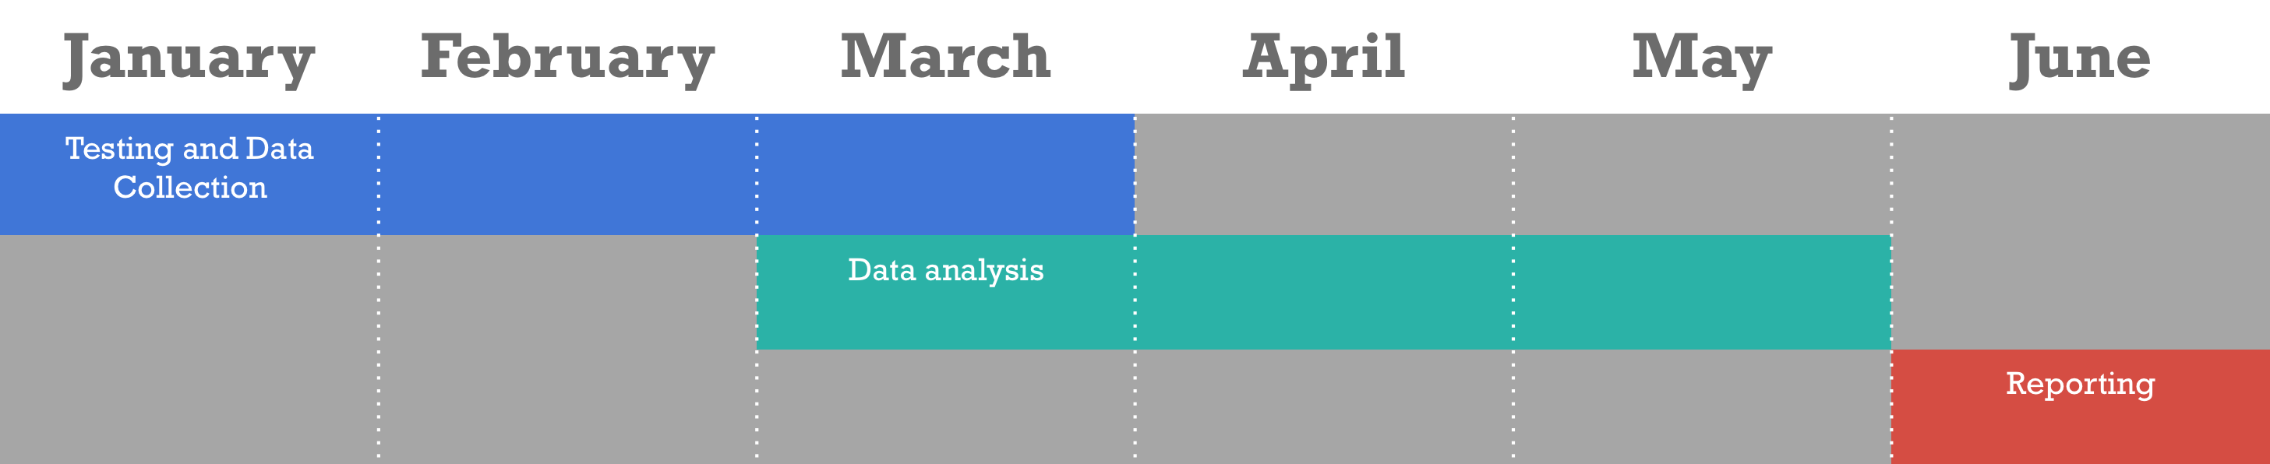
Figure 1. Timeline

Literature Review

The first usage of the word “docent” appears in a 1906 Museum of Fine Arts, Boston bulletin article written by J. Randolph Coolidge, the temporary Director of the museum at the time. In 1915, Benjamin Ives Gilman, the Secretary of the MFA Boston wrote “the exchanges between visitors and docents should not be like those between teacher and student, but more like those between friends, undertaken ‘in the spirit of free intercourse, not in that of compulsion, in the spirit of play and not of work’” (Burnham & Kai-Kee, 2011, p. 21). Fast-forward nearly 100 years and the field has reinterpreted interpretation countless times, responding to changing conceptions of museums, education, and society. As our world becomes increasingly complex, Burnham and Kai-Kee suggests that educators will continue to re-conceptualize their approaches to facilitating interpretive experiences and also suggests that by understanding the field’s past, we can better inform the future.

Relating to the role docents play in the aesthetic education of visitors, Mihaly Csikszentmihalyi suggests that the majority of museum visitors have great uncertainty regarding what to do in front of works of art, which they often view as containing language specific to a time and community outside of their own. With this in mind, Csikszentmihalyi claims that a visitor who is adept at finding significant meaning in an artwork is one who has been situated conceptually in the relevant period, is skilled at critically engaging with works, and has a certain emotional responsiveness to connecting with the human experience of another as expressed through an artwork. Thus only when some kind of aesthetic education has taken place is a visitor likely to have a full aesthetic experience (Lankford, 2003). This is not to say that visitors come to experiences completely uninformed. As suggested in Lachapelle, Murray, and Neim’s (2003) discussion of “aesthetic understanding,” (Lachapelle, et al., 2003) visitors come not as blank slates but rather with knowledge that they combine with the experiential and theoretical knowledge they potentially gain during a museum visit.

About Visual Thinking Strategies

A common methodology utilized by art museum educators to facilitate experiences is Visual Thinking Strategies (VTS), a teaching method that focuses on “open-ended yet highly-structured discussions of visual art” (Visual Thinking Strategies, 2012). The technique has been in circulation since 1995 and involves the teacher using a series of three open-ended questions in rotation (“What’s going on in this picture?” “What do you see that makes you say that?” and “What more can we find?”), alongside paraphrasing and linking student responses together (ibid) so as to formulate a collaboratively constructed interpretation of the artwork being examined. The technique avoids the usage of information and is solely focused on exploration so as to develop student “aesthetic and language literacy and critical thinking skills” (ibid).

Researching the Interpretation of Art

The function of interpretation/learning in the art museum is an understudied topic in the field of museums, with much research and writing “in the arts and in museums but [not] in art museums” (Luke & Adams, 2012, p. 2). Luke and Adams note that “no one theory can accommodate the complex, non-linear, and multi-dimensional nature of learning in art museums” and that “art museum research is largely descriptive” and “current research provides rich descriptions of art museum experiences, but little indication of cause and effect within these experiences” (ibid, p. 8-9). Compelling fragments concerning interpretation did arise throughout their survey of research in the field, however. For instance, in a 1997 study conducted by Gay, Boehner and Panella, it was concluded that university students visiting art museums felt that “in a museum they were not always assured of a ‘partner with whom to converse and often felt as if the museum environment discouraged verbal interaction” (1997). Furthermore, a Twiss-Garrity study in 1995 suggests that visitors’ ability to access artwork relies not on their “age, prior experience knowledge, or familiarity with art or museums” but rather on their “personal references or interests” (1995). In questioning the educational function of art museums, a Getty Center for Education in the Arts study in 1991 noted that visitors identified numerous desired takeaways from experiences in art museums, including “arousal of intellectual curiosity; increased understanding of content or subject; enhanced appreciation of the beauty, age, and craftsmanship of objects, increased understanding of technique and media; and opportunities for communication about related and unrelated subjects” (1991). Overall, Luke and Adams suggest that further research is needed on this subject, as current studies “hint at the broad and complex nature” of outcomes concerning learning but few studies are comprehensive and thorough enough to speak too much beyond a specific institution or experience (Luke & Adams, p. 2).

Methods

Due to the broad range of goals to be evaluated, this formative/summative evaluation relied on mixed methods including tour observations, visitor interviews, visitor surveys, and data collector surveys.

Data collection took place January through March 2012. During this time period, 55 tours were scheduled to take place. Due to data collectors’ availabilities, we planned to evaluate 48 tours. 10 of these 48 tours were cancelled due to either the lack of visitor-participants or guides, leading to a total of 38 tours observed. From these 38 observed tours, 29 visitors agreed to be interviewed and surveyed.

1. Tour Observations

The tour observation component of this evaluation was designed to address the following goals:

- Visitors will “see” (look closely) and interact with the art
- Facilitate a shared and collaborative learning experience

Through these unobtrusive tour-observations, both the visitors and Gallery Guides were observed to understand the correlation between Gallery Guide actions and visitor behaviors. Specifically, certain visitor behaviors indicative of engagement, including pointing/gesturing, stepping forward, and nodding along with visitors’ statements and questions were tallied. Additionally, Gallery Guides’ VTS questions and interpretive/informative statements were tallied. To clarify each of the indicators to be tallied, an observation key was also created (appendix B).

Independent variables related to the settings in which each tour took place were also recorded, including the specific exhibition being toured, the number of visitors per tour, the number of pieces discussed per exhibition, and the tour length. This information was collected to determine if they might have a bearing on the goals’ occurrence.

For a detailed view of the tour observation instrument, see appendix A.

2. Visitor Interviews

To complement the observations, interviews were conducted with randomly selected visitors following each tour. The iPad program AudioNote was used to record these interviews. Selected visitors were asked the following open-ended questions:

1. What will you remember most tomorrow about the tour you went on today? Why?
2. Is there anything else that stuck in your head as particularly interesting? Why?
3. Is there anything you are curious about right now? Why?

This set of questions aimed to address the following goals:

1. Visitors will create a memory
2. Visitors will experience a sense of wonder

Sampling

Random sampling was used to select which visitor would be interviewed. Specifically, at the end of each tour, the visitor standing at the far left of the group was selected. If this person refused to be interviewed, then the person standing to the far right of the group was approached. A total of 29 visitors were interviewed.

3. Visitor Surveys

Each visitor selected for an interview was also asked to participate in a brief survey (see appendix C). These surveys were created in the program iForm Builder and facilitated through the use of an iPad. The selected visitors were asked the following questions:

1. Which three words best describe how you feel after the tour?
(Visitors were provided with a list of words to choose from and were given an option to add their own word if desired).
2. Which three words do you feel best describe the tour?
(Visitors were provided with a list of words to choose from and were given an option to add their own word if desired).
3. On a scale from 1-8, how comfortable would you be leading a friend through the Frye after your experience today?
4. On a scale from 1-8, how likely would you say you are to go on a tour next time you visit an art?

This set of questions aimed to address the following goals:

1. Bring the artwork to life
2. Visitors will be more likely to have a future personal interaction with art

Per the Frye’s request, general demographic-based information was also collected through the surveys including how many times the visitors had visited the Frye in the past 12 months, how many times they had participated in a guided tour in an art museum in the past 12 months, and their age range.

Sampling

The same visitors selected through the random sampling method described above took part in the survey. A total of 29 visitors were surveyed.

4. Data Collector Surveys

Because of the large number of data collectors (12) and in anticipation for the possible variations between tours, each data collector was asked to complete a post-tour survey (see appendix D). This allowed for further contextualization of data from the observation and the interview/survey. Although 32 data collector surveys were completed, the surveys did not indicate any major anomalies or disruptions during the tours. Only answers provided to the question, “How many people came and went?” were used to inform this evaluation.
Results

1. General Findings:

a. Age demographics
During the 38 tours observed, the age demographic of each participant was recorded. As the figure below (figure 2) demonstrates, the majority (53%) of visitors participating in the Frye’s public tours were above the age of 51.

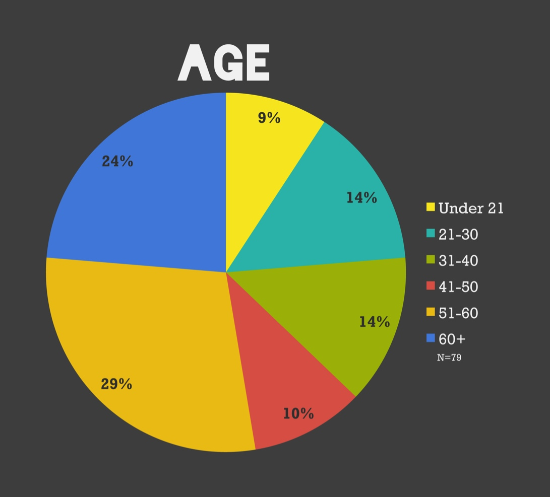
Figure 2. Age Distribution

b. Museum visitation information:
In the survey, visitors were asked how many times they had visited the Frye and participated in a tour in an art museum in the past 12 months. For most of the 29 surveyed visitors, their tour experience in an art museum was the first in the last 12 months (52%), as was their visit to the Frye (68%).
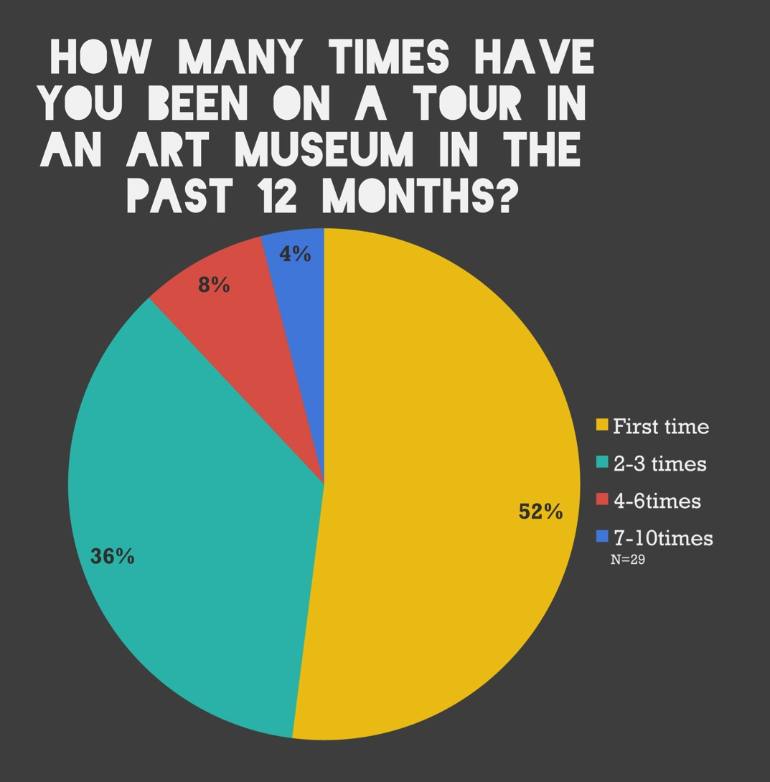
Figure 3. Tour Participation

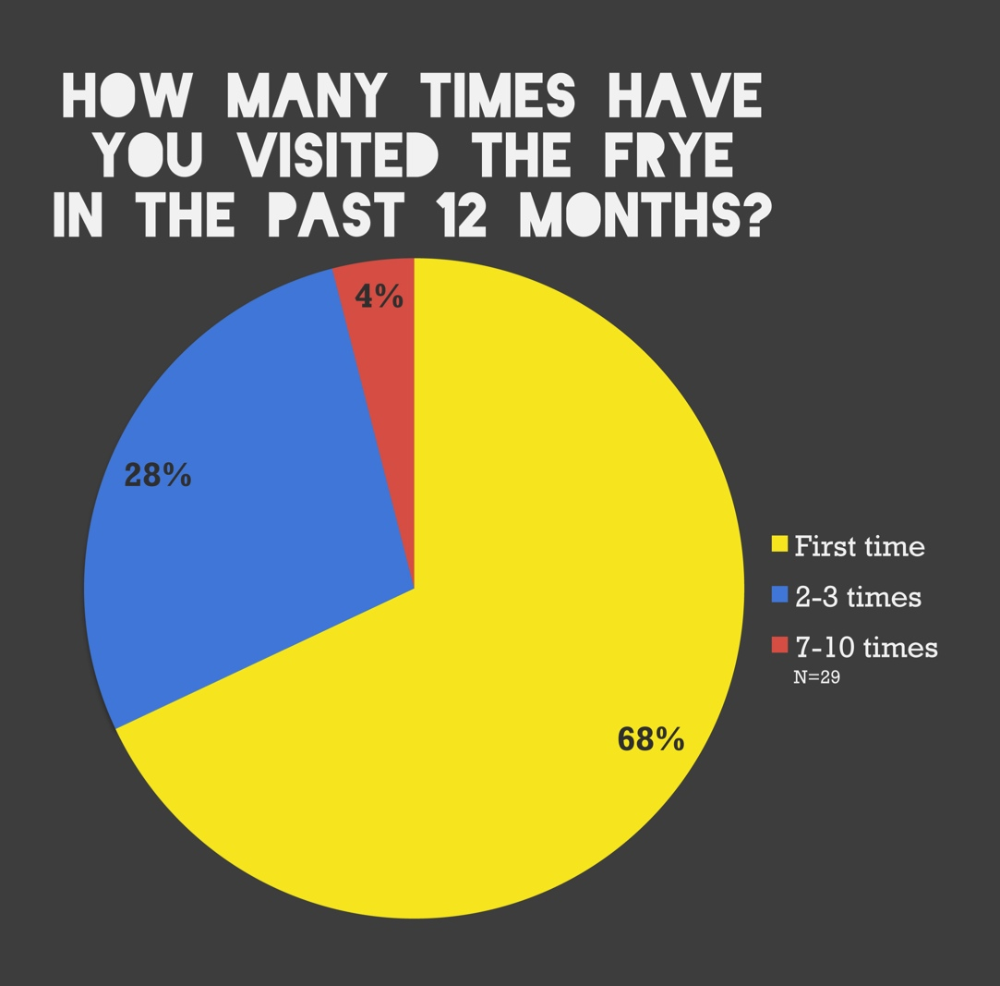
Figure 4. Frye Visitation

b. Tour lengths:
As the figure below (figure 5) demonstrates, tours varied greatly in length, ranging from 21 minutes to 2 hours.

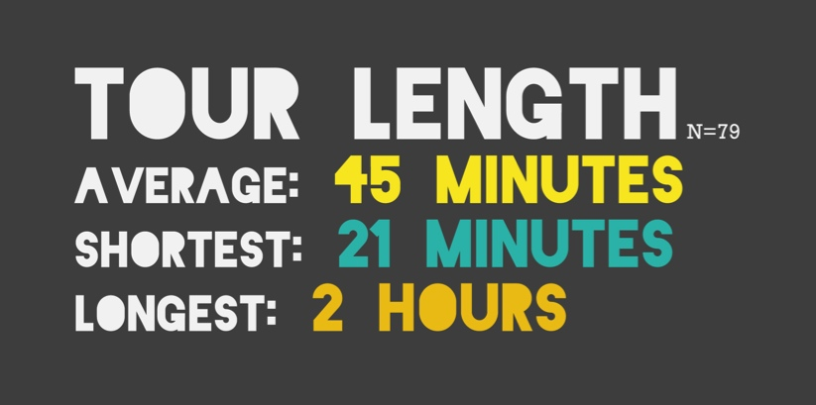
Figure 5. Tour Length

c. Visitors’ coming and going
Data collectors kept track of the amount of visitors that came and went during the tours. As demonstrated below (figure 6), the majority of tours were malleable, experiencing a high level of visitor flux.

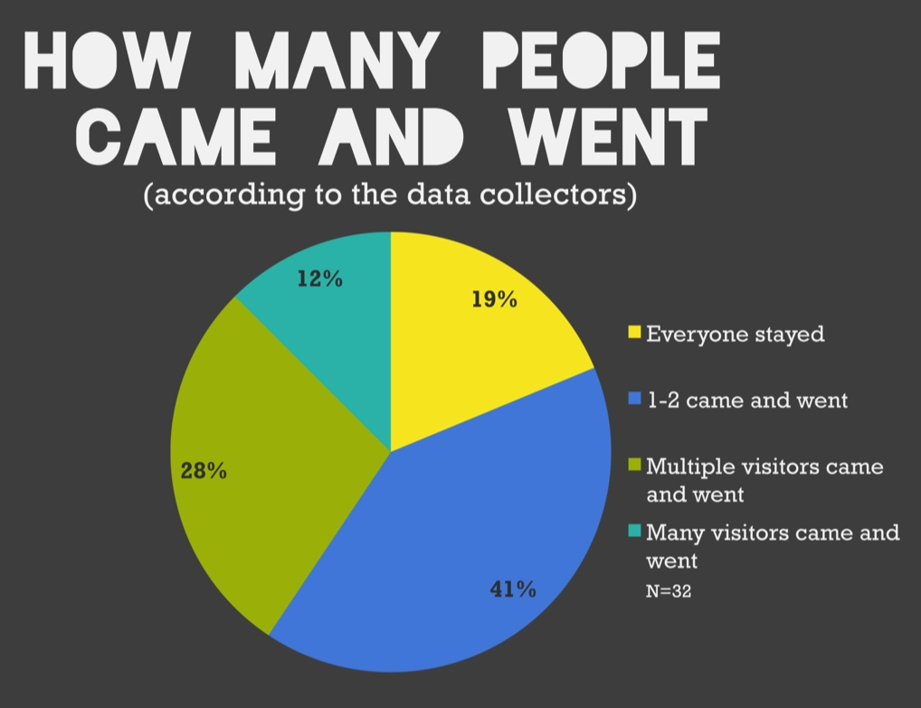
Figure 6. Tour Size Fluctuation

d. Tour description
In the survey, visitors were asked to select 3 words they would use to describe the tour from a bank of 12 words. As demonstrated below (figure 7), visitors felt the tours were collaborative, informative, and fun more than anything else.

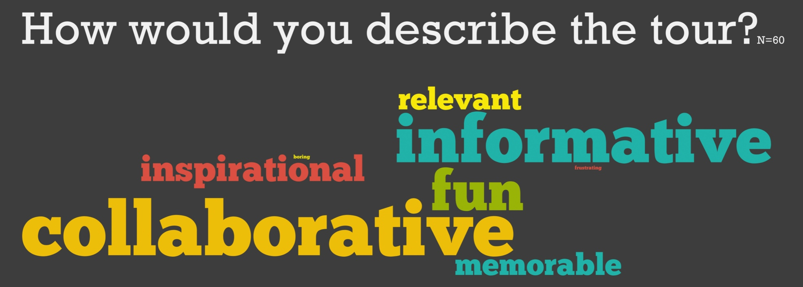
Figure 7. Visitors’ Tour Description

e. Post-tour feeling
In the survey, visitors were also asked to choose 3 words that best described how they felt after the tour from a bank of 12 words. As demonstrated below (figure 8), they reported feeling stimulated, inspired, curious, and connected with others more than anything else.

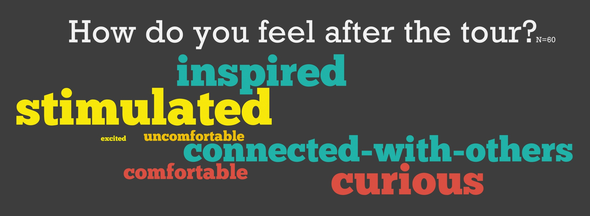
Figure 8. Visitors’ Post-Tour Feelings

2. Goals

Goal 1: Visitors will create a memory
In the interview, visitors were asked what they would remember most tomorrow about the tour they had just went on. Most visitors listed multiple items as particularly memorable. As demonstrated below, visitors brought up a specific piece (N=11) and the group experience (N=11) most frequently.

Main Themes | Sub-Themes | Quotes
A specific piece (11) | N/A | “If I was to tell people why I would come back here for or remember…this piece here, right when you enter” (points to Eternity)  “Some of the paintings (of the permanent collection) I had not seen before”  “The pictures from the Layman because they were so weird”
The group experience (11) | Interaction with participants, group size, getting to talk with Frieda | “What I’ll remember most is actually the interaction that was brought out, not just with the pictures themselves, but between the people…I’m glad that all the people participated”  “Enjoying the group discussion”  “I liked getting to talk to Frieda” (Exhibit Curator)
The interaction with the guide (7) | Guide’s knowledge, interpretation, and approach | “Her explanation…the discussion around Eternity, I would have never known what was going on”  “I like how the guide got us thinking about what it all meant rather than just looking and ranting”  “I felt the tour guide was very knowledgeable and allowed us to speak freely”  “She gave us the option to choose”
The different perspectives of the tour participants (6) | N/A | “The other people saw different things than we did and it enriched the experience”  “It’s very easy to have your own opinion about a work of art and not see anything else…I definitely had a different opinion of that piece to begin with until somebody had mentioned something that caught my eye and changed my attitude about what I thought about it”  “A fantastic interchange of personalities and artistic perceptions (…) that was encouraged”
Interaction with the art (broadly) (5) | Getting to look and talk about the art on view | “Looking at the pictures a little differently than I would have if I had just walked in an looked at them.”  “Getting to better understand each piece”  “Opportunity to learn about the art”
A specific exhibit (5) | N/A | “I thought the Li Chen exhibit was very interesting”
Learning about the Frye (4) | Charles and Emma Frye, the museum’s history | “I didn’t know that their money was still tied to the land in Seattle…I always wondered how they could be free”
Table 3. Visitors’ Memories

Goal 2: Bring the artwork to life
In the survey, visitors were asked how comfortable they would feel leading a friend through the Frye after their tour experience. The average of all 29 responses was a 7 on an 8-point scale (figure 9).

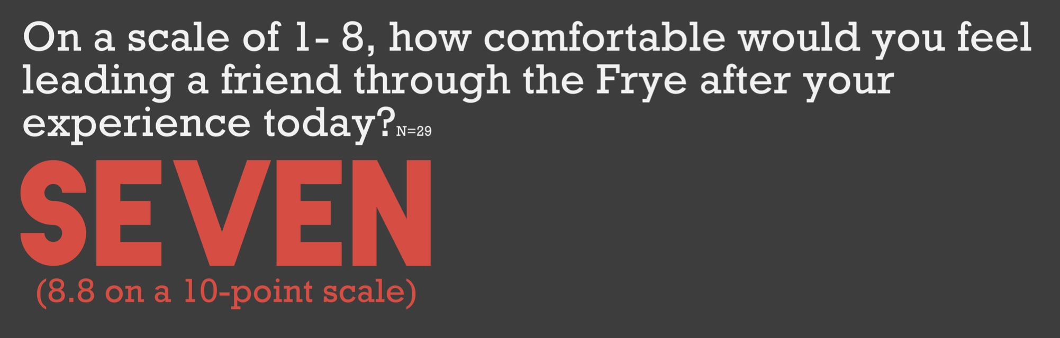
Figure 9. Visitors’ Post-Tour Comfort Level

Goal 3: Visitors will experience a sense of wonder
In the interview, visitors were asked if there was anything they felt curious about regarding their tour/museum experience. Although 8 visitors did not express a strong sense of curiosity after their tour experience, most visitors (n. 14) expressed feeling curious about such things as a specific work (n. 6) or artist (n. 5).
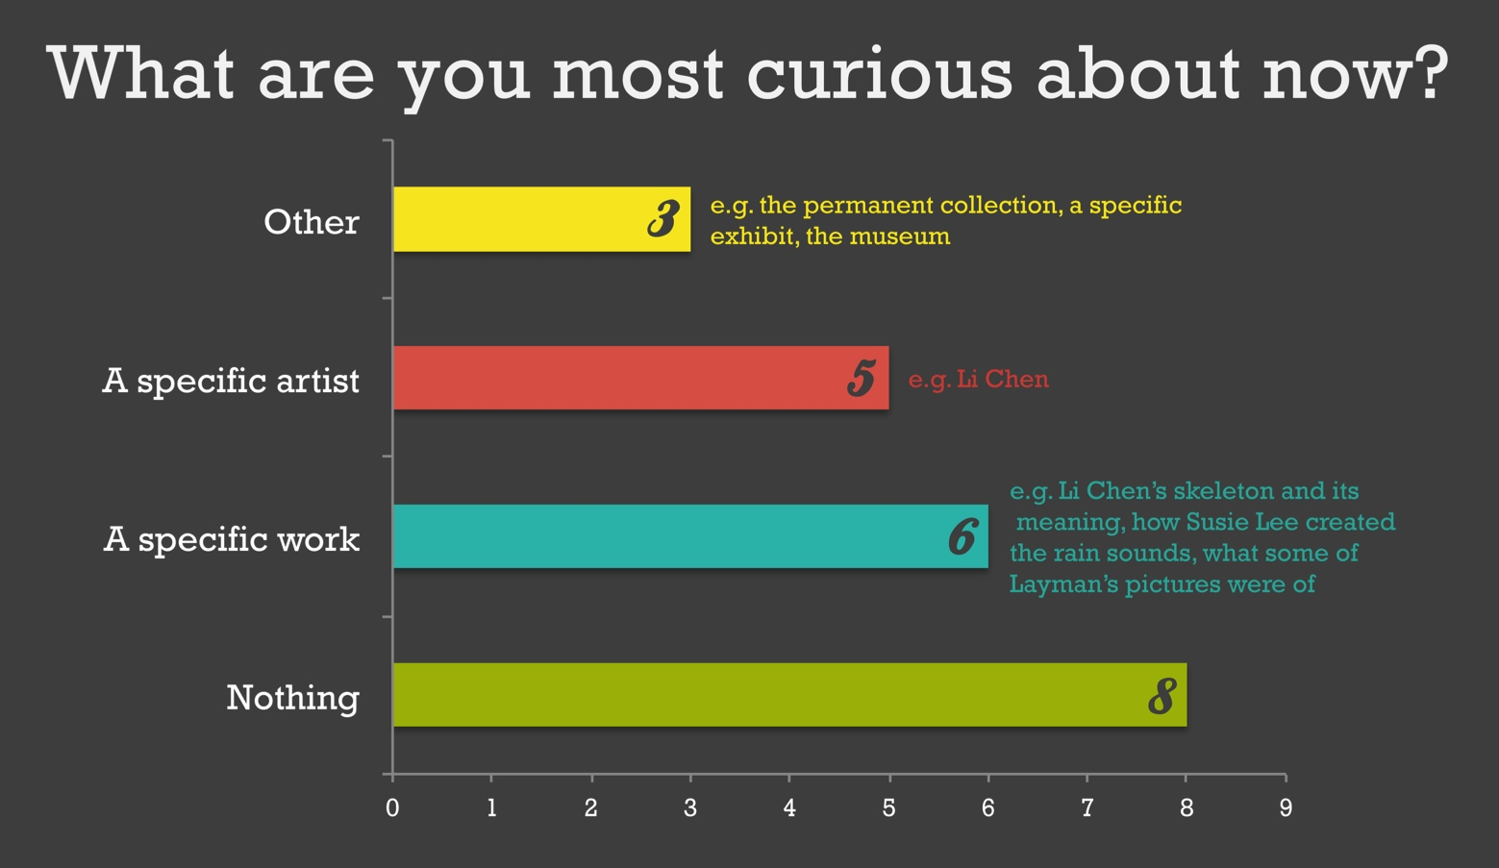
N=22
Figure 10. Visitors’ Expressed Curiosities

Goal 4: Visitors will “see” (look closely) and interact with the art
As displayed in the chart below (figure 6), the visitors’ most frequent form of verbal engagement consisted of making statements both to the group and other visitors. Questions to either the Gallery Guide or another visitor were less frequent. Based on behavioral observations, visitors appear to have been actively engaged, going beyond simply nodding to examining the artwork in greater detail.

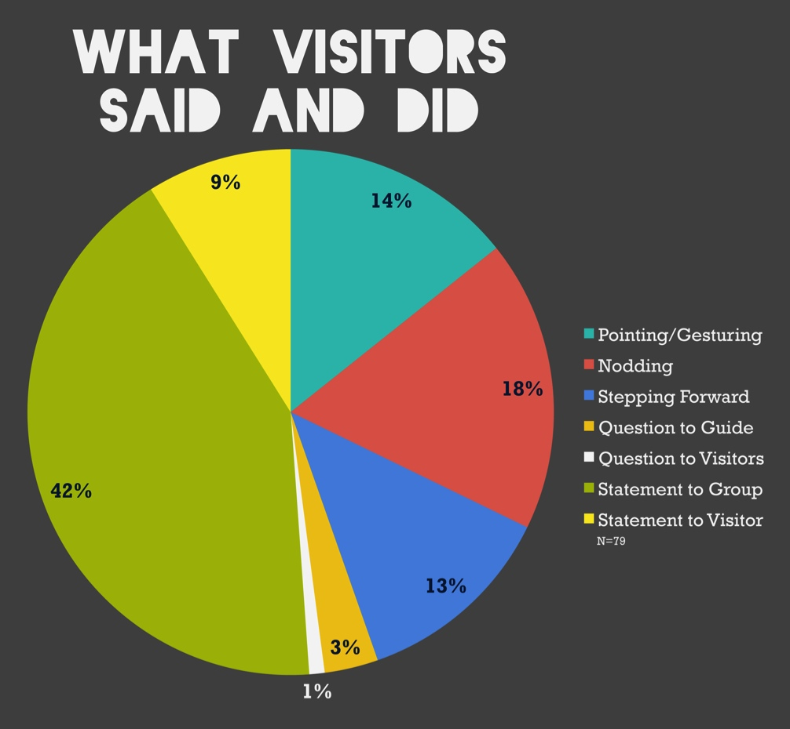
Figure 11. Visitor Statements and Behaviors

Goal 5: Facilitate a shared and collaborative learning experience
The figure below (figure 12) represents the breakdown of all the Gallery Guides statements that took place during the tours. Overall, they used informative statements most, followed by sharing their interpretations and utilizing the three VTS questions “What do you see,” “What makes you say that” and “What more can we find?” For their part, visitors engaged most by making statements to the whole group either as a response to a Gallery Guide or visitor statement (figure 13). Both the memory references and comparisons point to the occurrence of goal 2, “bring the artwork to life,” as visitors were drawing on their previous knowledge to make sense of what they were experiencing on the tours.
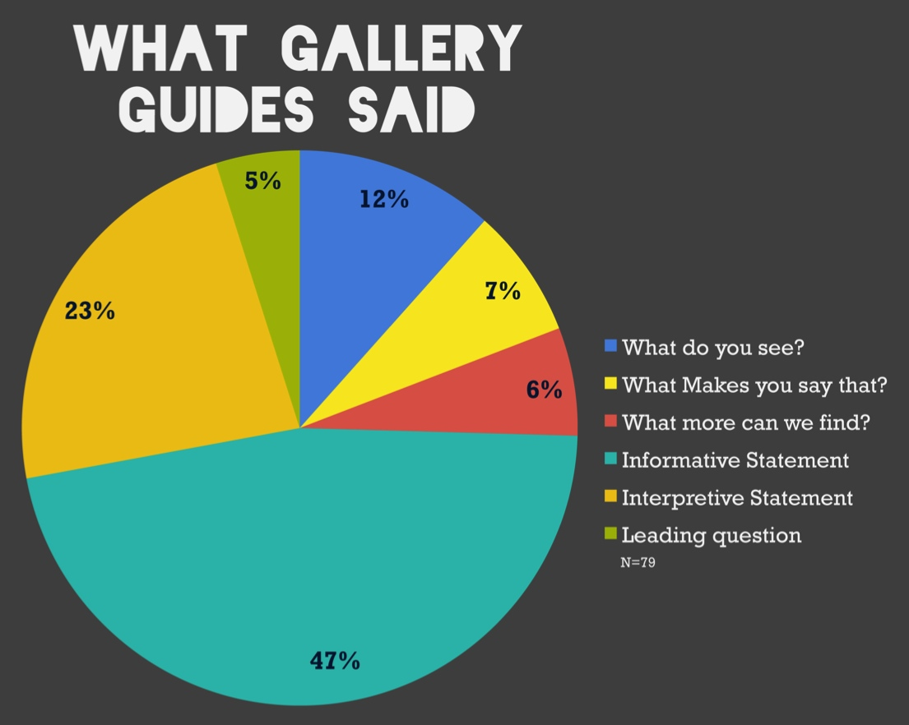
Figure 12. Gallery Guide Statements

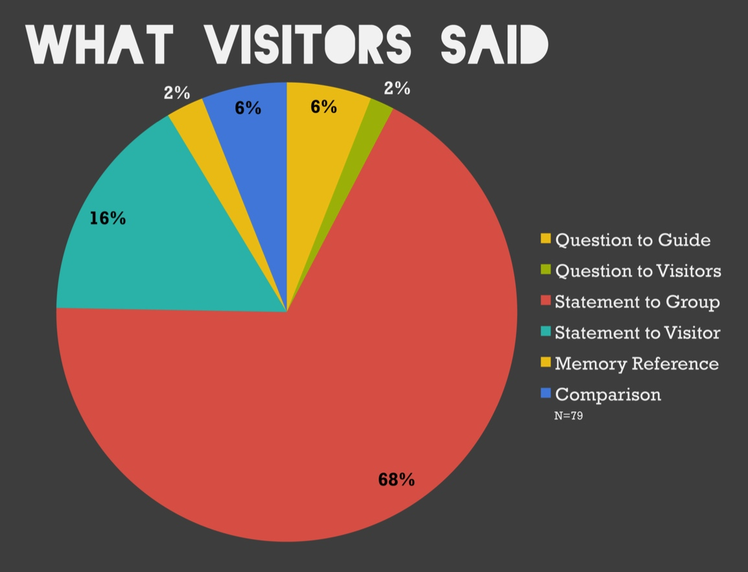
Figure 13. Visitors’ Verbal Engagement

Goal 6: Visitors will be more likely to have a future personal interaction with art
In the survey, visitors were asked how likely they would be to go on a tour next time they visit an art museum. On an 8-point scale, visitors’ responses averaged a 7.

Figure 14. Visitors’ Likelihood to Go on Future Tours
Discussion

1. Significance

As the museum had never looked into who participates in their public tours and how visitors engage during these tours, the primary significance of our data is that it provides baseline information for the museum. Now the Frye has a better idea of tour participants’ age demographics, museum visitation frequency, and the organic nature of the tours. Furthermore, considering that the Gallery Guides are primarily trained in the VTS method, the Frye was surprised to learn about the amount of informative and interpretive statements used by the Guides. The museum can utilize this information regarding the tours’ diversity when training Gallery Guides to facilitate tours.

2. Limitations

- Due to the goals’ diverse nature, an evaluation looking at the occurrence of one or two goals could provide more in-depth information. For instance, some goals, such as goal 6, could be better measured longitudinally.

- With the amount of visitors coming and going during the tours, we quickly realized that it was often impossible to properly tally the exact number of people participating in a single tour.

- In trying to keep track of each tour participant’s age range, we realized that it is often difficult to be sure of what age range they belonged to.

- The overwhelming variety amongst the tours (in number of visitors, length, Gallery Guide style, etc.) made interpreting the data particularly difficult, thus it was decided to keep the findings as descriptive as possible.

Conclusion
Overall, findings suggest that there was great variety amongst tours. For example, all tours were malleable in nature, ranging from 21 minutes to 2 hours in length and consisting of 1 to 30+ visitors who came and went with great frequency. Another element impacting the tour experience was the diversity amongst the Gallery Guides’ tour facilitation styles. Each Gallery Guide had a unique approach, blending both VTS/inquiry and information/personal interpretation to elicit visitor responses.

Despite the range in tour experiences, all goals were met to varying degrees during the tours. For instance, all interviewed visitors identified something particularly memorable about their experience (goal 1). Additionally, visitors expressed a greater level of comfort in the museum/with the artwork as a result of their experience and expressed interest in participating in future tours, even though nearly 70 % were first time visitors (goal 2 and 6). Finally, visitors expressed interest in learning more about the artwork on view (goal 3) and expressed having been impacted and satisfied with the collaborative nature of their tour experiences (goal 5).

Acknowledgements

We wish to express our gratitude to the instructors and advisors of the New Directions in Audience Research initiative, Kathryn Owen, Nick Visscher, and Kris Morrissey, for their guidance; to Jessica Luke for being our project’s reviewer; and to the staff and volunteers of the Frye Art Museum for sharing their tours with us.

References

Burnham, R., & Kai-Kee, E. (2011). Teaching in the Art Museum: Interpretation as
Experience. Los Angeles: Getty Publications.

Diamond, Judy (2009). Practical Evaluation Guide: Tools for Museums and Other Information Educational Settings. Walnut Creek, CA: Alta Mira Press.

Gay, G., Boehner, K., & Panella, T. (1997). ArtView: Transforming image databases into
collaborative learning spaces. Journal of Educational Computing Research, 16(4),
317-332.

Getty Center for Education in the Arts (1991). Insights: Museums, visitors, attitudes,
expectations: A focus group experiment. Malibu, CA: J. Paul Getty Museum.

Lachapelle, R., Murray, D., & Neim, S. (2003). Aesthetic Understanding as Informed
Experience: The Role of Knowledge in Our Art Viewing Experiences. The Journal of
Aesthetic Education, 37(3), 78-98.

Lankford, E. L. (2002). Aesthetic Experience in Constructivist Museums. The Journal of
Aesthetic Education, 36(2), 140-153.

Luke, J., & Adams, M. (2012). What Research Says about Learning in Art Museums.
Annapolis, MD: Institute for Learning Innovation.

Twiss-Garrity, B. (1995). Learning how visitors learn: A Winterhur experience. In the
Sourcebook: Museums educating for the future (pp.102-109). Washington, D.C.:
American Association of Museums.

Visual Thinking Strategies. (2012). What is VTS?. Retrieved from
http://www.vtshome.org/what-is-vts.

Appendix A
Tour Observation Instrument

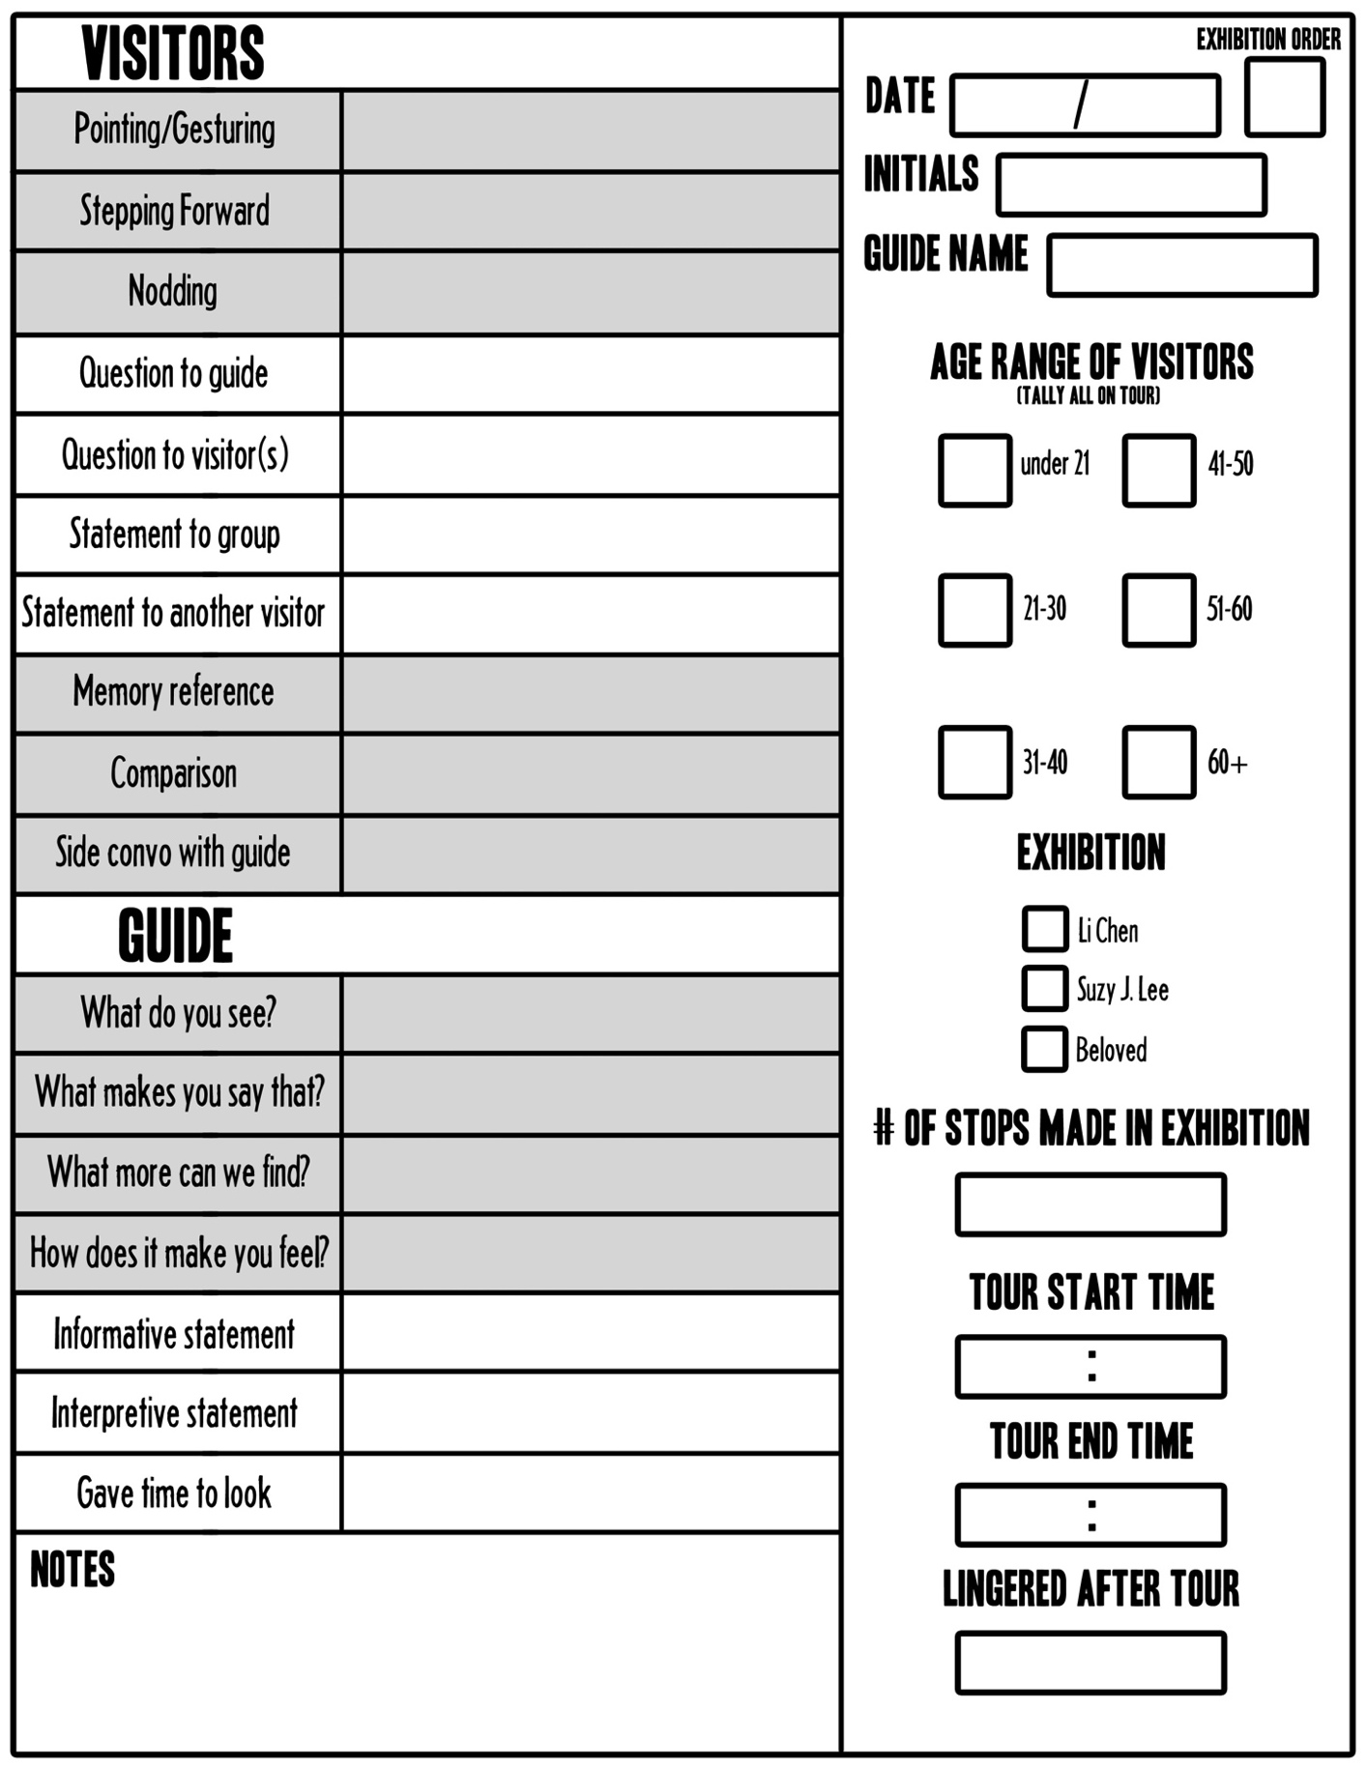
Appendix B

Observation Key

Pointing/gesturing: visitors point to the artwork (usually while talking/describing)
Stepping forward: visitors move closer to the artwork to take a better look
Nodding: people nod their heads to what the guide or another visitor is saying.
Question to guide: question addressed specifically to the guide
Question to visitor(s): question addressed specifically to another visitor(s) (e.g. to clarify something that visitor said)
Statement to group: statement to “the ether”
Memory: “it reminds me of,” “I’ve seen something like that before”… direct reference to the past. A memory reference could also be a comparison (e.g. people comparing other artwork that they’ve seen at the Frye or elsewhere)
Comparison: people compare specific piece to another or an object (e.g. “this makes me think of a flower). A comparison could also be a memory statement only when it directly refers to the past
Side convo with guide: visitor has a side conversation with the guide (usually between pieces)
What do you see?: “what’s going on here,” “what do you see in this picture”
What makes you say that?: guide probes the visitor to explain his response
What more can we find?: guide encourages further participation
How does it make you feel?: guide inquires about visitors’ feelings (like-dislike…)
Informative statement: guide provides information related to historical context, artist, etc.
Interpretive statement: guide provides personal interpretation of work (“when I see this, I think…”) or references other tours’ interpretation (“other visitors have said…”)
Gave time to look: guide gives the visitors time to look around at the work before leading the discussion

Appendix C
Visitor Survey
ONLY ORAL RESPONSES
1. What will you remember most tomorrow about the tour you went on today? Why?
2. Is there anything else that stuck in your head as particularly interesting? Why?
3. Is there anything you’re curious about right now? Why?

SURVEY AND ORAL RESPONSES
4. Which three words best describe how you feel after the tour? Any other word?
Inspired Frustrated Comfortable Confused Uncomfortable Curious Bored Connected-with-others Stimulated Mentally-tired Excited Overwhelmed

5. Which three words do you feel best describe the tour? Any other word?
Boring Collaborative Difficult Relevant Memorable Frustrating Inspirational Mentally-tiring Discouraging Informative Physically-tiring Fun

6. On a scale of 1 to 8, how comfortable would you be leading a friend through the Frye after your experience today? Why?
Very uncomfortable < 1 2 3 4 5 6 7 8 > Very comfortable

7. How many times have you visited the Frye in the last 12 months?
☐ This was my first time ☐ 2-3 times ☐ 4­6 times ☐ 7-10 times ☐ 10+ times

8. How many times in the past 12 months have you participated in a tour at an art museum?
☐ This was my first tour ☐ 2- 3 times ☐ 4-6 times ☐ 7-10 times ☐ 10+ times

9. On a scale of 1 to 8, how likely would you say you are to go on a tour next time you visit an art museum? Very unlikely < 1 2 3 4 5 6 7 8 > Very likely

10. Age Range: Under 21 / 21-30 / 31-40 / 41-50 / 51-60 / 60+
Appendix D

Post data-collection survey

DATE_______________
INITIALS_______________

1) If your tour visited multiple exhibitions, how would you rank the level of visitor engagement in each from highest (1) to lowest (2 or 3)?
_____Susie J. Lee: Of Breath and Rain
_____Li Chen: Eternity and Commoner
_____Beloved: Pictures at an Exhibition

Please explain your ranking. Did you notice certain works eliciting greater response? Were there problematic works? Why so?
________________________________________________________________________________________________________________________________________________________________________________________________________________________

2) Based on your observations, how many visitors came and went during the tour (choose one answer)?
c Everyone stayed on the tour the entire time
c One or two visitors came and went
c Multiple visitors came and went
c Many visitors came and went

3) What three words would you use to describe your gallery guide’s approach?
________________________________
________________________________

