Holding Power of Seattle Aquarium Exhibits for the Toddler Audience

Seattle Aquarium
Summative Evaluation
New Directions Project
Spring 2011

Research Team: Kaleen E. Povis & Andrea Barber
Report reviewed by Nick Visscher, Kris Morrissey and Kathryn Owen

Funded by:

New Directions Partner Institution:
Executive Summary
The Seattle Aquarium seeks to discover how toddler families experience its exhibits and how to best incorporate toddler family needs in future exhibit developments. The goal of this study is to begin to document toddler-exhibit interactions in order to better understand the Aquarium experience for that audience. The specific research goal was to determine which exhibit elements are attracting and holding the attention of the toddler family audience.
A total of 47 caregiver interviews and 297 toddler observations across three exhibit areas were collected from January-March 2011 at the Seattle Aquarium. Results suggest that, in general, the exhibit elements that were attracting the most toddlers were also the elements with the highest holding power. Additionally, caregiver perception of which elements are and are not appealing to their toddler aligns, for the most part, with the patterns of use seen in the exhibit observations.
- The Family Activity Center (FAC) and the Hands-on Hallway had comparable average dwell times at 130 and 129 seconds, respectively. However, the distribution of time across exhibit elements differs. Time in FAC was distributed across multiple exhibit elements. In the Hands-on Hallway 75% of time spent was concentrated around the felt board.
- While the Octopus Area had the lowest average dwell time (74 seconds) it contained the exhibit element with the highest toddler attendance (85%). This exhibit element, the octopus tank, also had the second highest holding time (38 seconds) across the three exhibits.
- The four exhibits with the highest percent of toddler attendance also had the highest holding times.
  - Top Four Elements by Percent Attendance
    - Octopus Tank (85% of toddlers)
    - Felt Board (65% of toddlers
    - Orca Audio Buttons (57% of toddlers)
    - Orca Fin (45% of toddlers)
- Top Four Elements by Holding Time
- Felt Board (100 seconds)
- Octopus Tank (38 seconds)
- Orca Fin (30 seconds)
- Orca Audio Buttons (26 seconds)
- 85% of all caregivers interviewed were interested in a toddler-focused exhibit area. When asked what they would like to see in the exhibit space, 61% of all responses were requests for interactive elements.

Introduction
As part of New Directions, the researchers of this study collaborated with staff from the Seattle Aquarium to embark on an evaluation of the aquarium’s exhibits over the course of the 2010-2011 academic year. New Directions in Audience Research is an IMLS funded project designed to train museum studies graduate students to understand, support and engage in audience research. A key component of the training is using museums as learning laboratories where students work with an institution to conduct audience research under the guidance of evaluation mentors and support staff.
Project Background
The Seattle Aquarium is a scientific, museological institution located in Seattle, Washington that focuses on living collections and researches marine life. The mission of the Seattle Aquarium is “to inspire conservation of our marine environment.” Part of this mission is achieved through the Aquarium’s exhibit floor which is composed of several exhibits highlighting different marine climates. In addition to these exhibits, on-site classrooms are used for public and school programs.
Some of the Aquarium’s public programs, such as Toddler Time, specifically serve the toddler audience. Evaluating the experience of this audience is a priority of the Seattle Aquarium. The Aquarium has undergone many changes in its exhibits over the past decade, and further plans are in development. At one point it was an institutional focus to incorporate early childhood learning into exhibits, but some of these elements have been removed in recent years. Therefore, the Aquarium seeks to discover how the pre-kindergarten family group experiences the institution in its current iteration. Knowing which of the current exhibit offerings are being used by this audience could serve to inform future exhibit changes.

This two-part visitor study aims to provide information to better understand this group of visitors. The first part of the study was quantitative in nature and focused on three of the Aquarium’s exhibit areas: the Octopus Area, the Hands-On Hallway, and the Family Activity Center. Toddlers were unobtrusively observed in these select exhibit areas. Where they stopped, how long they stayed, and what they did while at each element within the exhibits was noted. The second part of the study provided toddler caregivers an opportunity to share how they experience the Aquarium with a young child and what exhibit features they see as appealing to their toddler. This qualitative information was gathered through interviews with caregivers during Toddler Time.
Purpose Statement
The Seattle Aquarium seeks to discover how toddler families experience its exhibits and how to best incorporate toddler family needs in future exhibit developments. The goal of this study is to begin to document toddler-exhibit interactions in order to better understand the Aquarium experience of the toddler family audience.
Evaluation Question
Which exhibit elements are attracting and holding the attention of the toddler family audience?

Literature Review
Steve Yalowitz’s and Kerry Bronnenkant’s 2009 article on tracking and timing was the primary influence for the design of this study. In this article, they state the importance of discovering what visitors attend to and for how long. The approach they have found “most useful has been for each institution to compare across their own exhibitions by routinely gathering the same data in the same manner.” Unobtrusive visitor tracking involves detailed recordings of where visitors go and what they do. Thus, these studies can provide “quantitative data in relation to stay times as well as other behavioral data.” Such tracking studies have become a common means to understand and measure the success of an exhibition. In addition to tracking visitors, Yalowitz and Bronnenkant advocate for a mixed methods approach and suggest coupling interviews with observations.

Similarly, in the report Family Experience of Splash Zone at the Monterey Bay Aquarium, mixed methods including observations and interviews were used to evaluate the family experience at an exhibit (People, Places & Design Research, 2002). In this study, adults and children were seen as two audiences from whom to gather information in order to understand the combined experience of the family unit.

Research on early childhood development in museum spaces suggests that multi-sensory exhibits can encourage learning opportunities. For example, kinesthetic and aesthetic learning behaviors have been observed in 4 to 6 year-old children across all different types of museums. These behaviors included being physically engrossed in exhibit activities, at times to the point of sweating, and appeared to be at their highest levels when the children were engaged with interactive exhibit spaces (Piscitelli, 2001). Another study on young audiences suggests that toddlers prefer shiny colors and categorized furniture as an exhibit element based on the interactions that can take place with those items (Danko-McGhee, 2006).

Methodology
A modified tracking and timing technique along with visitor interviews were implemented to provide information on how toddler families use three exhibit spaces at the Aquarium. For an explanation of the terms used as part of these methods, refer to the glossary (Appendix E) at the end of this report.
Timeline
This year-long evaluation looking at the toddler-exhibit experience was conducted by University of Washington Museology as part of the New Directions project. As such, the research plan was divided into three sections, aligned with academic quarters.
Fall 2010
October: Defined Project Scope
November: Instrument Design Phase
December 9th: Presentation of Research Plan
Winter 2011
January-March: Data Collection Phase
Students in the introductory audience research course assisted with data collection
Spring 2011
April -May: Data Analysis Phase
June: Presentation of Findings and Evaluation Report
Audience
Toddlers and their caregivers were the audience of interest. For this study, “toddlers” were defined as children who appeared to be 1-4 years old. This range included children who were old enough to walk, but appeared younger than school-aged.

Sample Size
A total of 297 observations were collected in the three exhibit areas. Researchers collected 97 observations in FAC and 100 observations at both the Hands-on Hallway and Octopus Area. Interviews with 47 caregivers were conducted for the qualitative portion of the study with caregivers who attended “Toddler Time,” a twice-weekly, semi-regular program at the Seattle Aquarium.
Sampling Method for Toddler Observations
Since the evaluation question seeks to determine how toddler families experience the Seattle Aquarium’s exhibits, systematic sampling of toddlers was conducted in order to acquire comparable numbers of observations at each exhibit studied.
Each exhibit area was assigned predetermined boundaries that encompassed the primary exhibit features. Once a toddler entered the boundaries of an exhibit, the toddler became the participant for an observation. If more than one toddler entered the exhibit at the same time, the toddler on the observer’s left was chosen for observation.
The researcher continued to track the toddler-exhibit interactions until the toddler exited the exhibit space. Toddlers were not tracked simultaneously. Only once the toddler subject exited the predetermined exhibit boundaries did the researcher begin a new observation.
Because this study seeks to answer which exhibit elements are attracting and holding a toddler’s attention based on physical behaviors, only toddlers who were free-moving were tracked for this study. Therefore, toddlers in strollers or in arms were not a part of this evaluation. Additionally, no observations were conducted when docents or Seattle Aquarium staff members were presenting programs in exhibit spaces in an effort to remove the variable of programming.

Sampling Method for Caregiver Interviews
Homogeneous sampling was conducted for the qualitative, interview portion of this study. Caregivers at Toddler Time were the intended interviewees since they provide valuable insight into the wants and needs of toddlers. Once an adult entered the program space with a toddler, the interviewer approached and asked the caregiver to participate in the interview. In an effort to increase response rates, the approach often occurred once the toddler was engaged at a play station. Since Toddler Time attracts repeat visitors, only adults who had not participated already were interviewed.

Instruments
The observation portion of this study includes three instruments, one for each of the selected exhibit areas. Using a modified mapping method, toddler behaviors were recorded in each of the selected exhibit areas. Where they stopped, how long they stayed, and what they did while at each exhibit element was recorded on the mapping instrument. Each map (Appendices A-C) contains diagrams of the area’s exhibit elements along with grids for logging how long key behaviors occurred at each exhibit element. Behaviors of interest included: stopping, climbing, pointing, touching, and using the element for its intended use.
The time spent at each exhibit element was recorded in order to establish exhibit “holding power.” That is, the length of time which exhibit elements are holding the attention of the given audience. In this case, that audience is toddlers and attention is defined in this study as the display of any of the above behaviors. Time spent exhibiting each behavior was recorded in order to further understand how exhibit elements are being used by the toddler audience and thereby offer insights into what kind of exhibit characteristics might be appealing to toddlers.
The interview portion of this study included a face-to-face open ended interview coupled with a picture sorting task. This short interview (Appendix D) was administered by the research leads in order to solicit the caregiver perspective of preferred exhibit spaces and gave caregivers an opportunity to reflect on the toddler experience the Seattle Aquarium provides. In addition to a series of questions, participants were asked to select from a set of eleven pictures the two exhibit elements which they view as most appealing to their toddler. Participants were also asked to select the two exhibit elements from the pictures which they saw as least appealing to their toddler. While sorting the pictures, participants verbalized their reasoning.

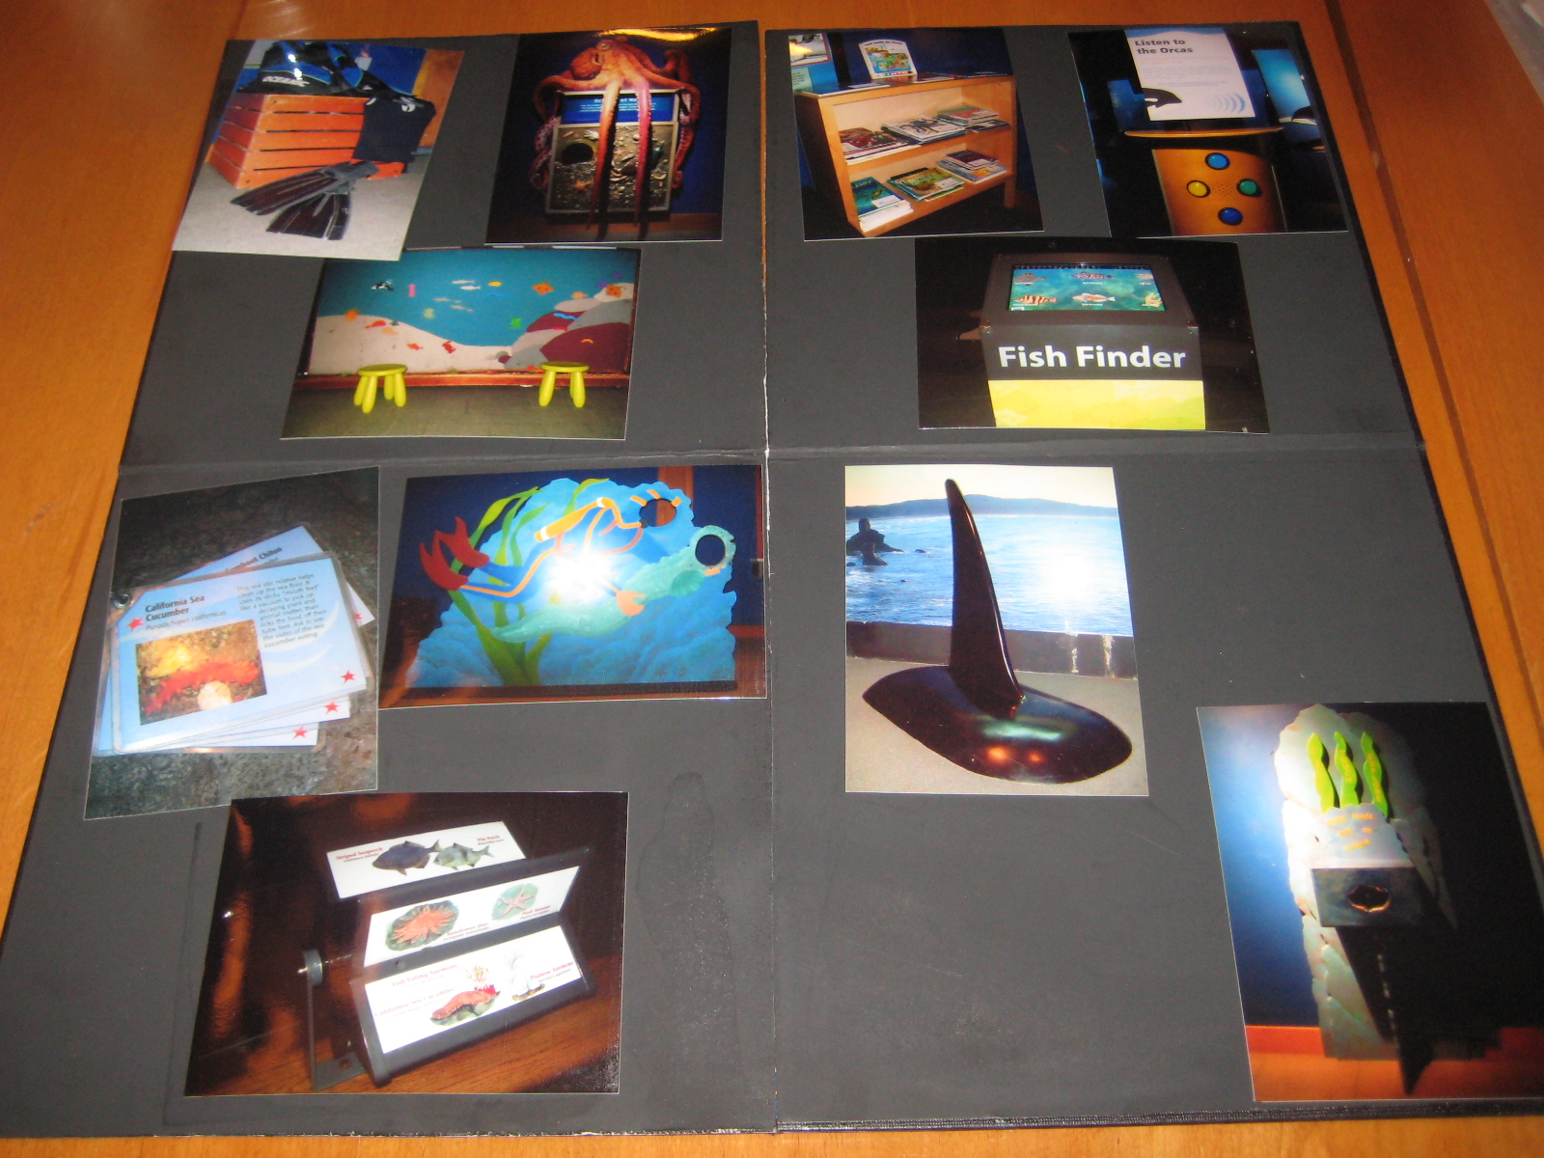
Photo: The Picture Sorting Activity

Data Analysis Methods
Observational data was analyzed based on measures of central tendency. Depending on the factors being analyzed, means, frequencies, and/or percentages were calculated. Caregiver interview data were categorized based on inductive coding. Multiple responses were each given a separate code. Percentages and/or frequencies were then calculated for these codes depending on the variables being analyzed.

Results
In total, 297 observations were completed, 97 in FAC and 100 in each the Hands-on Hallway and the Octopus area. Average dwell time in FAC (130 seconds) and the Hands-on Hallway (129 seconds) were comparable. The Octopus Area had an average dwell time of 74 seconds.

Figure 1: The Average Dwell Times per Exhibit Area
Though the Family Activity Center and the Hands-on Hallway show comparable dwell times, the distribution of that time differs. In the Hands-on Hallway, 75% of the time was spent with the felt board. Time in the Family Activity Center was more evenly distributed among the exhibit elements.

Figure 2: Hands-on Hallway Average Holding Time (in seconds) by Exhibit Element
While 75% of the time was spent at the felt board element, the other elements in the Hands-on Hallway were not completely ignored. The photo op attracted 41% of the toddlers observed and 23% attended to other elements.

Figure 3: Percentage of Toddlers who Attended to Hands-on Hallway Exhibit Elements
Time spent and the number of toddlers who attended to elements in the FAC was more evenly distributed. The average time spent at three of the exhibit elements (orca fin, orca buttons, audio center) exceeded 20 seconds. The orca fin and the orca buttons are among the top four elements for attracting and holding power. More than half of the toddlers observed (57%) attended to the orca buttons and 45% attended to the orca fin.

Figure 4: Family Activity Center Average Holding Time (in seconds) by Exhibit Element

Figure 5: Percentage of Toddlers who Attended to Family Activity Center Exhibit Elements
Although the Octopus Area had a lower dwell time than the other two exhibit areas, it contained the exhibit element (e.g. octopus tank), which attracted the largest number of toddlers and had the second highest holding time.

Figure 6: Octopus Area Average Holding Time (in seconds) by Exhibit Element

Figure 7: Percentage of Toddlers who Attended to Octopus Area Exhibit Elements
The four exhibit elements with the highest percent of toddler attendance (attracting power) also had the highest holding times (holding power). These four elements are the octopus tank, felt board, orca fin, and orca audio buttons. A few elements attracted around 40% of the toddlers observed, but did not achieve high holding power compared to the top elements. For example, 40% of toddlers attended to the octopus arms for an average of 14 seconds and 24% of toddlers attended to the skeleton closet for an average of 7 seconds.

Figure 8: Attraction and Holding Power across Exhibit Elements
The elements with the highest attracting and holding power were further examined in order to determine what types of behaviors were elicited at each element. Results indicate that the toddlers used the felt board and the audio buttons as they were intended to be used, while the orca fin elicited the most time spent climbing. Finally, attention stops accounted for the longest amounts of time spent at the octopus tank.

Figure 9: Time Spent Engaged in Behaviors at Most Used Elements
Interview Results
Of the 47 caregivers interviewed, 87% of all participants had visited the Seattle Aquarium with a toddler before. Members comprised 72% of our participants, and 28% of those interviewed were non-members.
When asked where caregivers spend most of their time with toddlers, a total of 54 coded responses were collected. The Touch Tanks, general exhibits (i.e. described general areas or three or more exhibits) and the Toddler Time Program were the longest-used areas according to the caregivers.

Table 1: Longest-used Areas According to Toddler Caregivers
Area | Frequency | Percentage (%)
Toddler Time | 8 | 15
Otters/Seals | 3 | 6
WOW | 5 | 9
Touch Tanks | 15 | 28
Octopus | 3 | 6
Jellyfish | 2 | 4
Tropical Fish | 3 | 6
Inside | 1 | 2
General | 13 | 24
Dive Show | 1 | 2
Total | 54 | 100
When asked what held the toddler’s attention in these areas, visual elements, general hands-on activities, and touching marine elements (animals and water) were the most frequent responses.

Table 2: Features that Hold Toddlers’ Attention
Element Feature | Frequency | Percentage (%)
Marine Touch | 14 | 25
Visual | 17 | 30
Hands-on | 12 | 21
Eye Level | 3 | 5
Interpreter | 8 | 14
Social | 2 | 4
Total | 56 | 100

Toddler caregivers were also asked if a toddler-focused area on the exhibit floor would be of interest to them. Of the 47 caregivers interviewed, 40 people (85%) said yes, 3 people said no (6%), and 4 people said maybe (9%).
If caregivers said they would like or would possibly like a toddler-focused exhibit area, they were then asked to describe what types of features they would want that area to contain. Of the 43 participants asked, 72 separate responses emerged. Interactive elements comprised 61% of all responses and were further coded into specific types of interactives, from art projects to interpreters in the exhibit space. Other features requested for a toddler-focused exhibit included visual elements, play equipment, closed/contained spaces, and low exhibit elements that could be accessible to toddlers.

Table 3: Toddler Exhibit Features Requested by Caregivers
Element Feature | Frequency | Percentage (%)
Visual | 4 | 6
Play | 5 | 7
Closed | 5 | 7
Low | 9 | 13
Interactives - Marine | 9 | 13
Interactives - Arts | 11 | 15
Interactives - Interpreter | 6 | 8
Interactives - General | 18 | 25
Other | 5 | 7
Total | 72 | 100

Toddler caregivers mentioned the felt board (62%) as the most appealing element to toddlers, followed by the orca audio buttons (38%), orca fin (32%), and octopus arms (32%). The least appealing elements from the picture sorting activity were the costumes (40%), info sheet (34%), and info star (26%).

Figure 10: Percentage of Responses for Photo Sorting Activity
Caregiver perception of which elements are and are not appealing to their toddler aligns, for the most part, with the patterns of use seen in the exhibit observations. For example 62% of caregivers selected the felt board as appealing and 65% of toddlers observed attended to the felt board. However, there were some discrepancies as well. The largest discrepancy between caregiver selection and toddler use was seen in the book nook. While 26% of caregivers selected bookshelf as appealing only 2% of toddlers observed attended to the bookshelf.

Figure 11: Comparison of Photo Sorting Activity and Exhibit Observations
Table 4: Comparison of Photo Sorting Activity Responses and Exhibit Observations
 | Rated Appealing | Rated Not Appealing | Toddler Use (%)
*Octopus Arms | 32 | 17 | 41
Info Sheet | 0 | 34
*Costume | 2 | 40 | 9
*Book | 26 | 4 | 2
*Photo Op | 19 | 9 | 41
*Touch Box | 0 | 19 | 17
Info Star | 2 | 26
*Felt Board | 62 | 4 | 65
Fish Finder | 17 | 13
*Audio Buttons | 38 | 9 | 57
*Orca Fin | 32 | 15 | 45
Discussion

While the Family Activity Center and the Hands-on Hallway show comparable dwell times, the distribution of that time differs. In the Hands-on Hallway, 75% of the time was spent with the felt board. Time in the Family Activity Center was more evenly distributed among the exhibit elements. Two factors may have been at play here. First, the range of possibilities with a manipulative like the felt board lends itself to extended use and the attracting power of this element may have overshadowed the other elements nearby. Conversations between toddlers and caregivers indicated that toddlers may have prolonged their stay at the felt board if not encouraged by caregivers to move on. Second, dwell time in FAC might have been effected by technological difficulties in getting an apparatus to work as intended.
Though the Octopus Area had a much lower dwell time, it contained the exhibit element with the second highest holding time. The high holding time at the octopus tank may be due to the presence of the octopus. However, since this was the only live animal included in this particular study there is no other reference point for comparison.
Holding times can be related to traffic flow issues, so knowing how long people are spending in one area can inform exhibit design changes. Similarly, exhibit design changes might come from knowing what elements are attracting, but not holding attention. For example, the octopus arms and skeleton closet attract 40% and 34% of the toddler audience, respectively, but only have a holding power of 14 and 7 seconds, respectively. In these instances an element is gaining relatively high attention, but does not seem to offer opportunities for engagement which would increase its holding power.

The top four elements that are attracting and holding the attention of the toddler are the felt board (100 seconds), octopus tank (38 seconds), orca fin (30 seconds), and orca audio buttons (26 seconds). The affordances of each of the most popular exhibit elements appear to be a factor in how toddlers interact with them. While the felt board uses fine motor skills, the tank is a visual experience, the fin involves gross motor climbing, and the buttons include auditory stimuli.
Holding power at the felt board was much longer than any other element examined in this study. This result may be due to its ability to be used by several visitors at once. Issues regarding crowd control are potentially minimized when several visitors can interact with an element simultaneously. However, during observations for this study, the felt board was often at maximum capacity due to the attracting and holding powers of the element. Repositioning the felt board so that the back is more accessible should increase its use by multiple visitors and decrease the instances of crowding.

Furthermore, a variety of different experiences were observed at the felt board over the course of data collection. Anecdotally, toddlers were seen sharing felt pieces with others, discussing names for marine animals and plants with caregivers, and categorizing felt pieces on the board. An info card set from the Tide Pool exhibit area was located at the felt board during one observation shift. During this shift, parents were observed reading the cards and relating the information to the toddler at the felt board which suggests marine life conversations may increase if more information were consistently provided at the felt board.
Hands-on activities and visual elements like bright colors and lights were described by caregivers as the features that hold a toddler’s attention. This caregiver response appears to be supported by the observations of toddlers in Seattle Aquarium exhibits. The largest allocation of time at the four most attended elements were attention stops, climbing, and using as intended. This data suggests that not only do the affordances and design of an element encourage certain types of attention behaviors and engagement in toddlers, but also elements that encourage a variety of different behaviors can be appealing to this age group.
Based on the interview vs. observation comparisons, it is evident that interviews alone may not be reflective of the actual behaviors occurring in the exhibit areas. Caregivers may accurately describe their toddler’s experiences (e.g. the use of the felt board) in some regards, but not others. For example, 26% of the caregivers interviewed chose the bookshelf as one of the two most appealing elements to the toddlers they were with, but only 2% of all toddlers observed engaged with the element when on the exhibit floor. Thus, mixed-methods are important to gaining an accurate view of exhibit use, and observations and interviews should continue to be coupled in future research.

Limitations
The quick pace of toddlers can be challenging to accurately record. Some aspects of their behaviors in exhibit spaces can occur quickly and may be missed while collecting data. The instruments used for the exhibit observations were created and modified in order to reduce this limitation as much as possible.
Data collection occurred primarily during the winter months, which may not reflect the general toddler visitor groups of the Seattle Aquarium. Seasonal differences in attendance and demographics may exist, but due to time constraints, only the winter season could be evaluated. Future studies could examine the toddler visitor during other seasons in order to obtain a more representative sample of this visitor group.
On occasion, events and school tours during data collection caused crowding in exhibit areas. The high population may have affected the accessibility of exhibit elements and the amount of time toddlers spent with these elements.
Interviews occurred during the “Toddler Time” program. This area had numerous elements and activities for toddlers to engage with and may have influenced the responses from caregivers. If the interviews took place in a more subdued environment, different responses may have emerged. However, Toddler Time was chosen as the environment for interview caregivers because toddlers were preoccupied and caregivers could devote their time and energy to thoughtful responses.

Conclusion
The results of this study indicate that a variety of exhibit elements are attracting and holding the attention of the toddler visitor. The four exhibit elements with the highest attracting power were also the exhibits with the highest holding power. Each of these four exhibits seems to facilitate a distinct sensory experience. The octopus tank is a visual experience while the felt board and orca fin are fine and gross motor experiences respectively, and though a tactile experience in part, the orca audio buttons include auditory stimulus. It should be noted that the holding power of the felt board was more than double that of any other exhibit element in the three observed areas which lends support to maintaining this exhibit feature. Additionally, attention should be paid to those exhibit elements that attract but do not hold toddler attention, such as the skeleton closet and octopus arms.
If the Aquarium chooses to design a permanent toddler exhibit area, as 85% of the caregivers interviewed indicated they would like, it would be beneficial to assess the needs of both toddlers and their caregivers. As the results of this study suggest, the assumptions of caregivers may not always align with what toddlers are observed to do on the exhibit floor.
Future Research
Since caregiver interviews indicated toddler-family units spend the majority of their time at Toddler Time and the Touch Tanks, future studies might include behavioral observations in these areas.

Additionally, repeating the study with another age group could provide a broader understanding of exhibit usage. Certain elements may attract and hold the attention of other visitors. Documenting this use may provide insight when developing exhibit elements that aim to encourage multigenerational interactions.
In the future, exhibit elements designed for the toddler audience could be prototyped during the Toddler Time program. Testing elements in this setting could provide insights into whether an item would be successful with the toddler audience on the exhibit floor.

Acknowledgements

New Directions advisors Kris Morrissey, Nick Visscher, Kathryn Owen, and Steve Yalowitz provided thoughtful guidance throughout this project. The Seattle Aquarium, especially, April Terrell, Ruth Yeomans, Sherry Williams, Kathy Sider, Katrina Bettis were gracious hosts. It was a pleasure to work with you all.

This project would not have been possible without the help of our team of data collectors from the introductory audience research course. Thank you, Emily Bailey, Chris Cadenhead, Ryan Horvath, Eric LaPlant, Siri Linz, Peder Nelson, Katie Phelps, Joseph Wapner, and Nara Zhou for your time and dedication.

References

Danko-McGhee, K. (2006). Favourite artworks chosen by young children in a museum
setting. International Journal of Education Through Art, 2(3): 223-35.

People, Places & Design Research. (2002). Family Experience of Splash Zone at the Monterey Bay Aquarium. Northampton, MA.
Piscitelli, B. 2001. Young children’s interactive experiences in museums: Engaged, embodied, and empowered learners. Curator 44(3): 224-229.
Yalowitz, S. and Kerry Bronnenkan (2009). Timing and Tracking: Unlocking Visitor
Behavior. Visitor Studies, 12(1): 47-64.

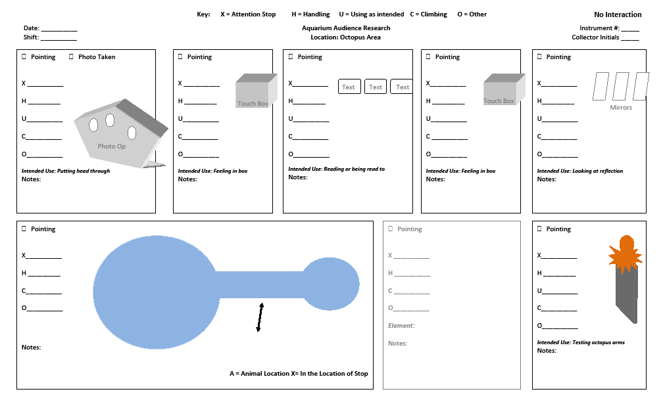Appendix A: Octopus Area Tracking Map

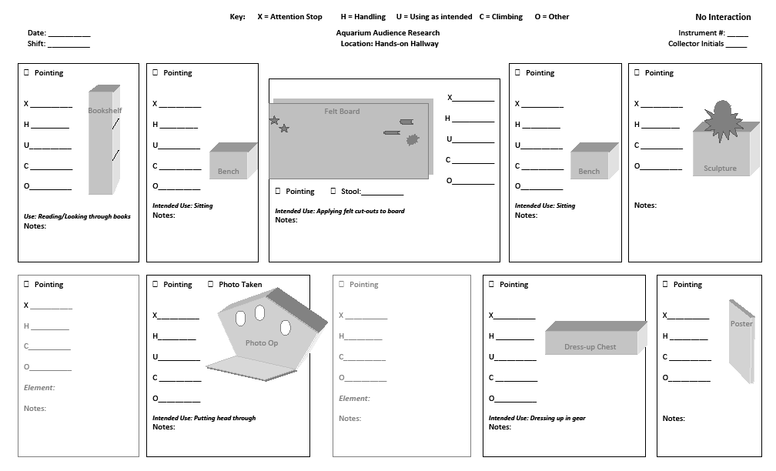Appendix B: Hands-on Hallway Tracking Map

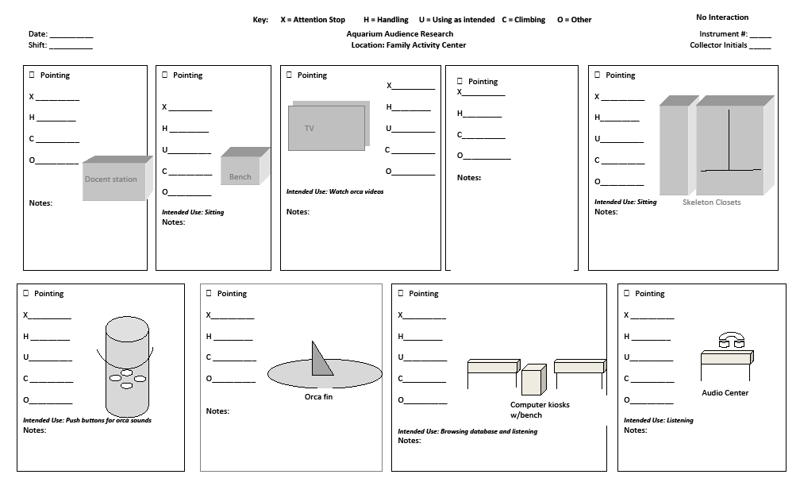Appendix C: Family Activity Center Tracking Map

Appendix D: Toddler Caregiver Interview
Have you been to the Seattle Aquarium with a toddler before? Yes No
In the past 12 months, how often have you come to the Aquarium with a toddler?
Are you a member of the Aquarium? Yes No

What does the Aquarium provide for a toddler that attracts you to visit?

When you visit the Aquarium with a toddler, where do you spend most of your time?

What seems to hold the toddler’s attention (there)?

What is one of your favorite memories of the toddler(s) in your group at the Aquarium?

How could the Aquarium help create more moments like that for you and the toddler(s) you’re with?

What tip would you give a person visiting the Aquarium with a toddler for the first time?

Would a toddler-focused area at the Aquarium be of interest to you? Yes No Maybe
What would you want that area to contain?

This last part is a quick sorting activity. There are ten pictures here of exhibit elements. Pick out the two you see as most appealing to your toddler and which two you see as least appealing to your toddler.
As you think, talk out loud, so I can better understand your reasoning.

Octopus Arms Info Sheet Costume Corner Book Nook Photo Op

Touch Box Info Star Felt Board Fish Finder Audio Station Orca Fin
Appendix E: Glossary

Attention: observable measure of a toddler engaged with a given entity over a period of time. The measures of attention for this study were an attention stop, climbing, handling, using as intended or other behaviors.

Attention Stop: toddler directs body toward an element and appears to be focusing on that element. Feet do not have to be planted to count as an attention stop.

Attract: drawing the attention of an individual.

Climb: using limbs to scale an object.

Element: a distinct exhibit component at which an individual toddler’s attention can be measured. Elements defined by researchers based on preliminary observations in each exhibit area.

Family Activity Center: the carpeted exhibit space called The Family Activity Center on the Seattle Aquarium map. This space does not include the marine mammal underwater viewing areas which are also present in the larger room.

Handle: physically touching an object with hands.

Hands-on Hallway: the hallway located between the Life on the Edge and Pacific Coral Reef exhibits. The boundaries of the hallway were determined as the imaginary line from the scuba cage to the wall, the imaginary line from the bookshelf to the wall and the imaginary line drawn across the opening to the Tropical Reef exhibit.

Holding power: the length of time exhibit elements hold the attention of a given audience.

Octopus Area: an area within the Life on the Edge exhibit which is titled “Giant Pacific Octopus” on the Aquarium map; is bordered by but does not include the “Life of a Drifter” jellyfish area and the “A Closer Look” tables.

Toddler: children who appear to be aged approximately 1-4 years old; they are old enough to walk but appear young enough to be pre-school aged.

Tracking and Timing: a quantitative empirical method where visitor traffic patterns and time spent in exhibit spaces are recorded.

Use as intended: observed as interacting with an exhibit element for its intended purpose, not just handling but performing a function (e.g. placing felt pieces on the felt board as opposed to just holding the pieces or touching the board).

Other: Toddler engaged in a behavior that does not meet the definitions of attention stop, climb, handle, or use as intended.

