Visitor Demographics & Motivation for Visiting the Henry Art Gallery
Henry Art Gallery
Front End Evaluation
MUS 597: DFW in Audience Research
Spring 2012

Research Team: Zaira Arredondo, Melissa Beseda, Allison Hoffmann, Kaylan Petrie
Report reviewed by Nick Visscher

Executive Summary
This front-end evaluation is part of an initiative for the Henry Art Gallery to develop an understanding of the demographic range of visitors, their inspirations for visiting the museum, and what visitor expectations are. Key findings are summarized below. Overall, these findings have three major implications.
- Wednesday, Thursdays and Fridays have the highest rate of visitation.
- Most visitors are not aware of The Reed Collection Center and the Digital Interactive Galleries (DIG) that are resources provided by the Henry for members, visitors, students, researchers and University of Washington staff.
- One third of visitors to the Henry Art Gallery are only utilizing Molly’s Cafe and do not visit the galleries.

Data for this evaluation was collected from 49 open-house attendees during a pilot test and 53 individuals during regular operating hours. All data was collected between April and May 2012.

Introduction
The Henry Art Gallery is the contemporary art museum on the University of Washington’s campus and was founded in 1926. The museum was expanded to 40,000 square feet in 1997. The layout of the museum is unique because visitors enter the museum on the main floor to access the James Turrell skyspace, Light Reign, and the North Galleries, then visitors descend two stories to access the café and additional galleries. The museum also provides access to the collection through the Digital Information Gallery, an online collections database that can be accessed with any internet connection, and in person through the Reed Collections Study Center. The Henry’s mission is to “advance the art, artists, and ideas of our time” which it lives out through bringing contemporary art and ideas to the Pacific Northwest to foster dialogue, debate, research, and learning. The diverse collection includes a historic and contemporary photographs, costumes and textiles, paintings, prints, drawings, and ceramics.
In addition to understanding the demographics of museum visitors, inspiration for visiting and visitor expectations, the Henry intends to use the findings to improve marketing and public image. The museum also wants to explore what makes the Henry unique to visitors who have the option of visiting other arts organizations in the Seattle area. Evaluations were conducted over the course of five weeks in two groupings, a pilot test during the Henry Art Gallery’s Open House event and later using our finalized instrument during regular hours. "New Directions is an IMLS funded project designed to train museum studies graduate students to understand, support and engage in audience research. A key component of the training is using museums as learning laboratories where students work with an institution to conduct audience research, under the guidance of evaluation mentors and support staff. "
*Who is coming to the Henry?
* What do visitors expect?
* Where are visitors coming from?
* When are visitors coming to the gallery?
* Why are visitors coming?

Literature Review
This front-end evaluation is the first of its kind to be conducted at the Henry Art Gallery. After speaking with representatives of the Henry’s staff about the museum’s desired outcomes it was essential to read literature of related evaluations that would enable us to create an appropriate evaluation plan for the Henry Art Gallery. Hallie Preskill’s article “Museum Evaluation without Borders: Four Imperatives for Making Museum Evaluation More Relevant, Credible, and Useful,” addresses the importance of having “courageous conversation” with key museum stakeholders, which means being willing to be vulnerable to the possible outcomes of the evaluation. This openness to the project was expressed when we met our site contacts and discussed what the museum would like to know and also that the institution would be open to any information we could provide as it would be beneficial to the Henry moving forward. This enabled our team to create an instrument that utilized both qualitative and quantitative data, another key aspect of Preskill’s article, to identify key information the staff wanted to know while allowing unexpected, yet useful information to surface.
Carole Henry’s article “ How Visitors Relate to Museum Experiences: An Analysis of Positive and Negative Reactions” and Randi Korn & Associates, Inc.’s evaluation Young Adult Study, address key factors for museums to have positive impacts on their audiences. The first is for museums to understand who their audience is. The Henry staff wanted to know who their audience is through collection of demographics and by asking key questions that identify the audience as stakeholders of the museum. Both Henry and Korn state that a welcoming environment creates positive experiences for visitors. A museum’s environment is a combination of both the physical and social factors. This evaluation will help the Henry’s staff understand how visitors interpret the environment of the Henry.

Methods:
The front end evaluation was developed, conducted, and analyzed over the course of 10 weeks during the spring 2012 quarter by this team in the University of Washington’s Museology Audience Research course. Participant ages ranged between 16 and 75 years old. The evaluation instrument was a fourteen-question survey that was either filled out by evaluators who conducted one-on-one interviews or by participants who filled out the surveys themselves. Pilot test evaluators collected evaluations from museum patrons in various areas throughout the museum. Evaluations collected during regular museum hours evaluators stood on the first level of the museum adjacent to the Digital Interactive Gallery (DIG) kiosk in order to collect evaluations from visitors coming up from the adjacent gallery, stairwell and elevator. Evaluators asked each visitor encountered to participate in the evaluation interview.

Results:
Evaluators collected 54 surveys during regular museum hours, 11:00am-4:00pm Wednesday, 11:00am-9:00pm Thursday and Friday, 11:00am-4:00pm Saturday and Sunday. As figure 1 shows 30% of visitors chose to participate in the evaluation, 31% stated they were only in the building for Molly’s Café, and 39% declined to participate. While this data appears to be negative, figures 2 through 8 provide an explanation for this imbalance. Molly’s Café is located on the mezzanine of the Henry Art Gallery and is open Tuesday through Friday 10am-3pm, Saturday and Sunday 10am-2pm; during hours when the café is open there was a higher number of evaluations collected and consequently a higher number of refusals. This data also indicates that the café attracts a number of visitor to the building, but many of those people only use the café and do not do not visit the museum galleries.
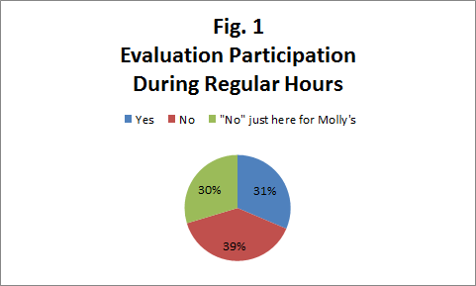
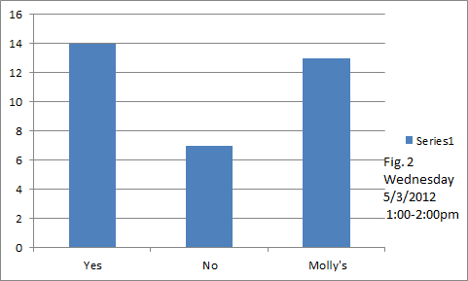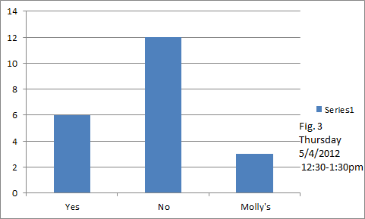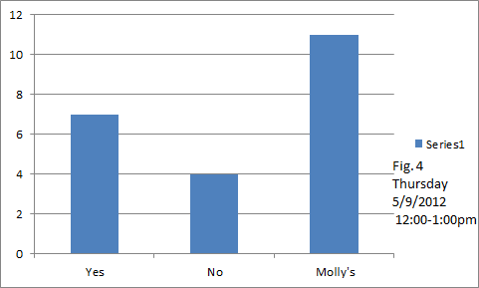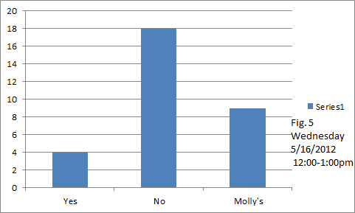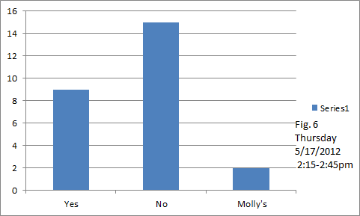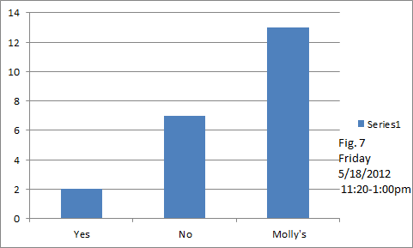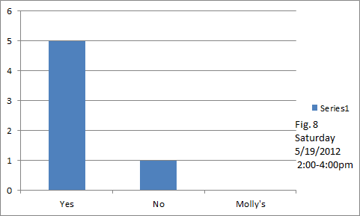

Participants were asked to identify their affiliation, if any, with the University of Washington. During regular hours, 59% of visitors claimed to be affiliated with the University either as a current student, alumni, or staff/faculty. 41% of responses indicated no affiliation with the University.
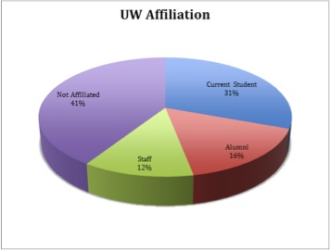
Figure 9 UW Affiliation During Regular Hours

During pilot testing, 72% of participants identified some affiliation with the university, while 28% said they had no affiliation. It should be noted that pilot testing was conducted during a special event where students were encouraged to attend and enroll for a student membership.
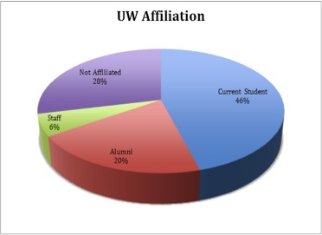
Figure 10 UW Affiliation During Pilot Testing

To provide additional information to the client about the visitor’s familiarity with the Henry, participants were asked how many times they had visited in the past year. The results during pilot testing and regular hours were nearly identical, in both instances indicating that approximately ⅓ of visitors had not been to the gallery in the last year, or ever.
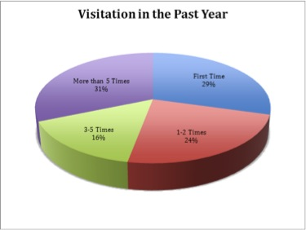
Figure 11 Gallery Visitation During Regular Hours

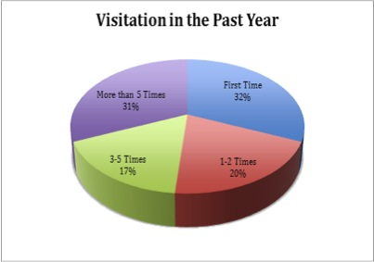
Figure 12 Gallery Visitation During Pilot Testing

Comprehending group composition is important in identifying appropriate museum experiences for different groups. Visitors were asked to express whether they came to the gallery alone, with a group of adults and children, or with only adults. During regular hours, 43% of visitors reported they had come to the gallery alone.
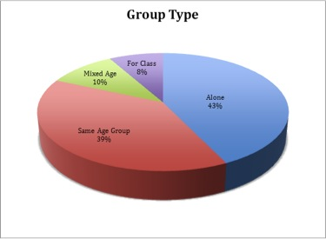
Figure 13 Group Composition During Regular Hours

During the pilot test, fewer individuals came individually, but due to the inherent social nature of the Open House event, the results may not accurately reflect the typical group composition at the museum.
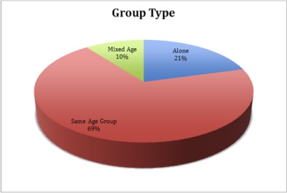
Figure 14 Group Composition During Pilot Testing

To understand how the Henry compares with other Seattle art organizations in terms of visitation, we asked our participants to chose from a list which arts organization in Seattle they have visited during the past year. During both the pilot testing and the regular hours data collection, the Seattle Art Museum and the Frye Art Museum had the highest mentions with 67% of the regular hours participants attending the Seattle Art Museum and 47% attending the Frye Art Museum during the past year. 55% of the pilot test participants attended the SAM and 32% attended the Frye Art Museum.
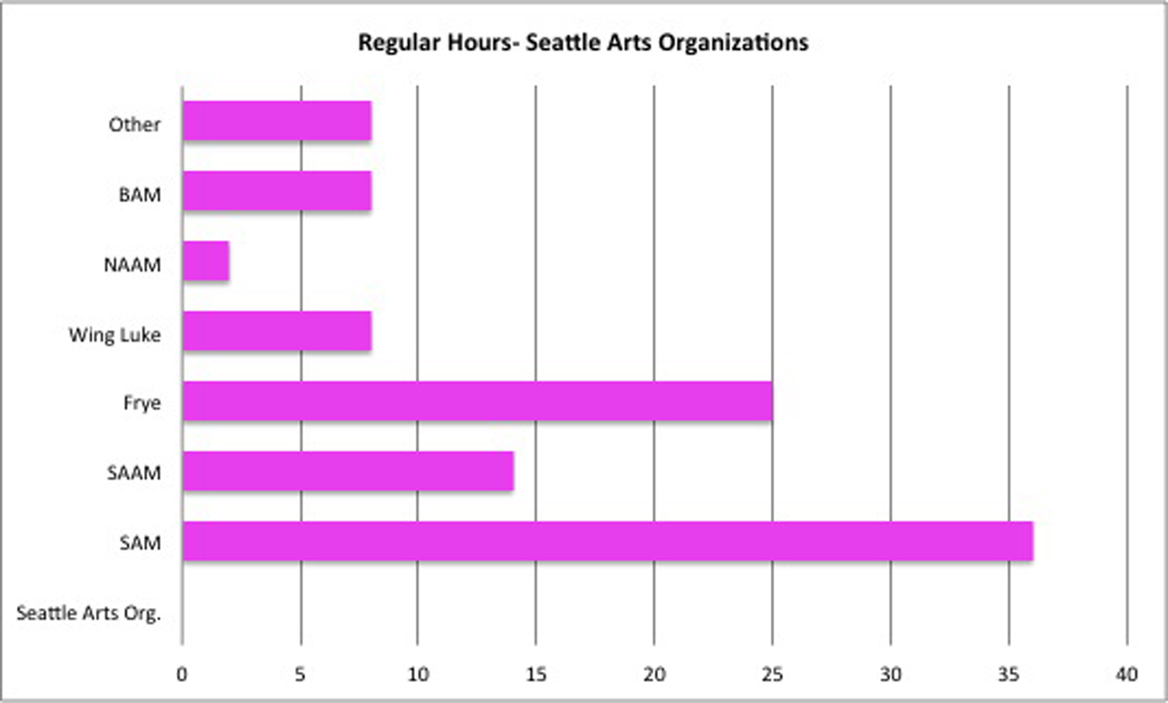
Figure 15 Seattle Arts Organizations During Regular Hours

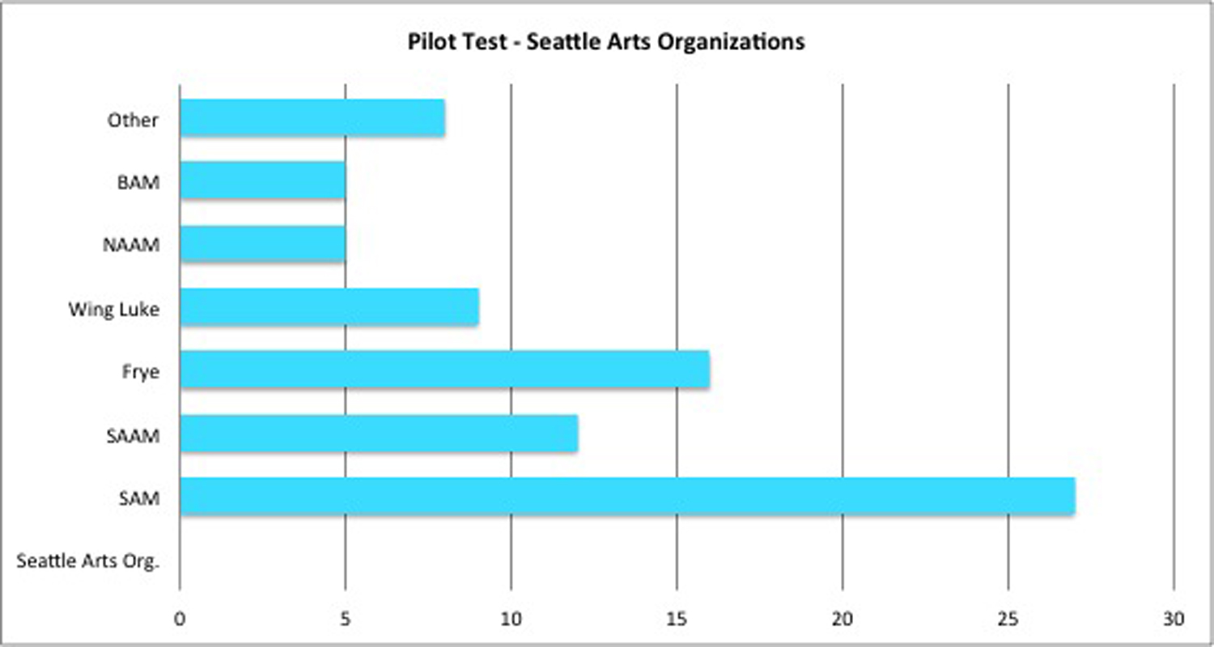
Figure 16 Seattle Arts Organizations During Pilot Testing

The Henry Art Gallery also wanted to know if visitors are aware of and use the resources available to research the collection, the Reed Collection Study Center and the Digital Interactive Galleries (DIG). Data collected during regular hours reveals that only 4% of the participants know of or have used the Reed Study Center, while 6% state they know of and/ or use the DIG module. During our pilot testing, however, the number of users of the Reed Study Center was as high as 14% and the users of the DIG module 21%. This may be due to the fact that a greater number of Henry’s members and UW affiliated visitors were attending the Open House during which the pilot testing took place.

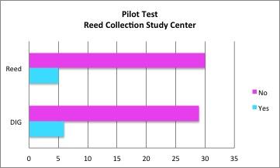
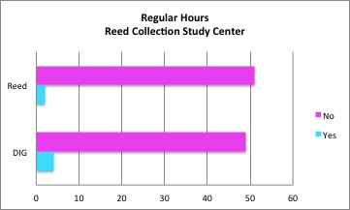
Figure 17 Study Center Regular Hours Figure 18 Study Center Pilot Test

In order to understand people’s motivations for visiting the Henry Art Gallery, participants answered the question what made them decide to visit the Henry today. During regular hours 26% of respondents mention Molly’s as the principal motivation to visit. Other common answers were interest in art in general (13%) and curiosity about specific exhibits (9%). Other motives included free time, bad weather, and meeting with friends and family.

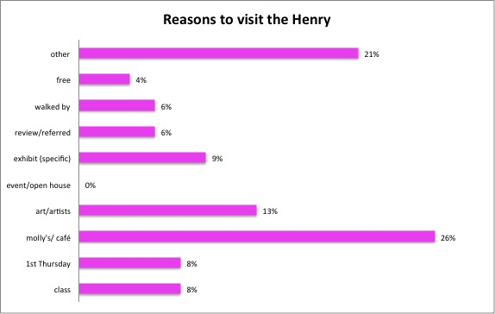
Figure 19 Reasons to visit. Regular Hours

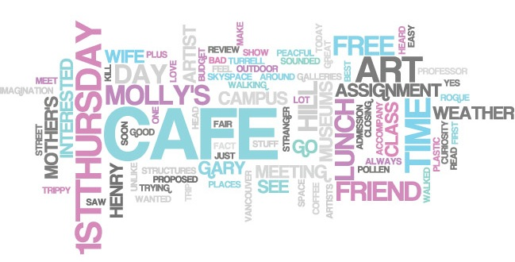
Figure 20 Reasons to visit word cloud. Regular Hours

The pilot test demonstrated that visitors were aware and engaged with the Special Events organized by the Henry. Visitors had not only heard about the Open House from friends, but also made it a fun Friday night destination. 53% of participants were at the Henry exclusively for the Open House.
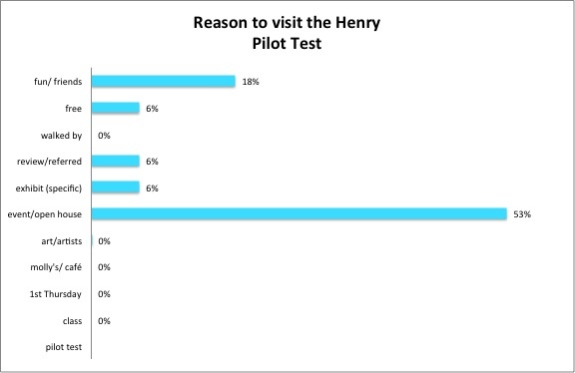
Figure 21 Reasons to visit. Pilot test.
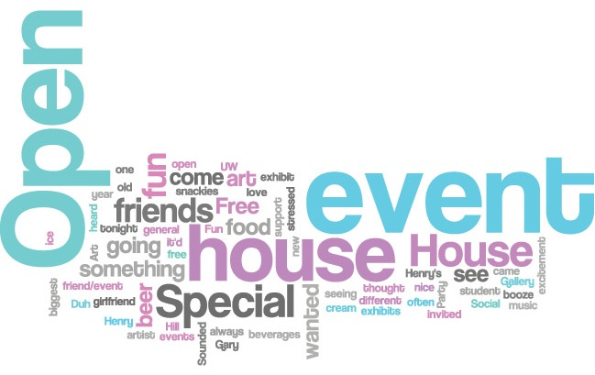
Figure 22 Reasons to visit word cloud. Pilot test.

In order to improve and develop the Henry’s mediums of communication with the visitors, we asked participants to tell us how they heard about the Henry. The most common response was “walking by” with 25% of the responses. Other common ways visitors are informed about the Henry are friend’s referrals, on-line search –does not include the UW website or Henry’s website–, reputation –“most famous”, “just moved in”, “first came in in 1983”–, and school class related referrals.
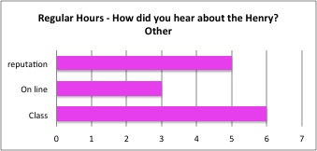
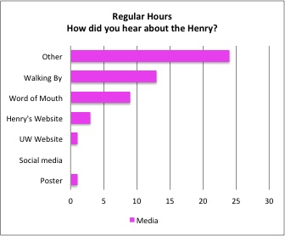
Figure 23 How did you hear about the Henry. Regular hours.

During the pilot test conducted at the Open House event, word of mouth was the most mentioned way visitors heard about the Henry. Many visitors also mentioned online presence and digital communication. There was a significant difference with the data collected during regular hours in which there was no mention of online related activity.

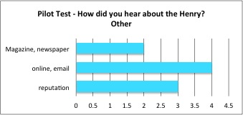
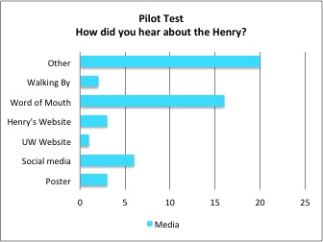
Figure 24 How did you hear about the Henry. Pilot test.

Other demographics:
 | Pilot Test | Regular Hours
% of Members | 23% | 57%
% of Artists | 49% | 40%
Average Age | 40 | 33

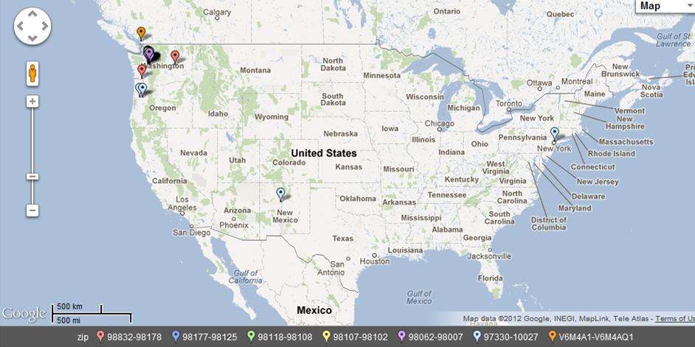
Figure 25. Henry Visitors’ home zip codes.

In order to ascertain where the Henry’s audience lives, we asked interviewees for their zip codes. Figure 25 above shows the plots of zip codes taken during our evaluation, with Figure 26 below zoomed in to the Seattle area. 75.5% of respondents were from the city of Seattle. 98102 (Capitol Hill / Eastlake) was the mode, with 6 people from that neighborhood.
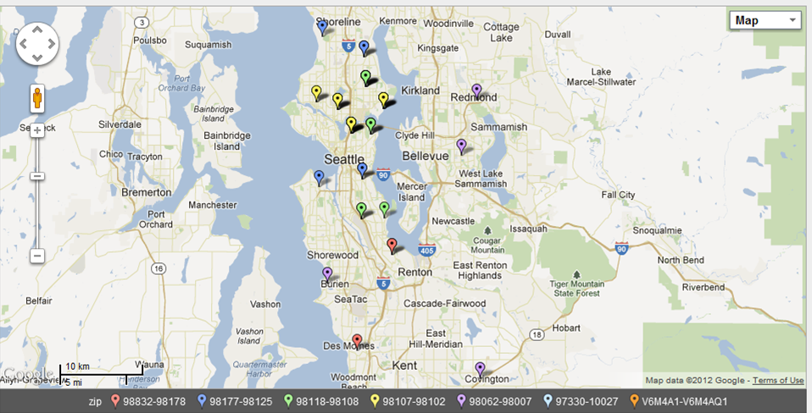
Figure 26 Henry visitors’ home zip codes in the Seattle area.

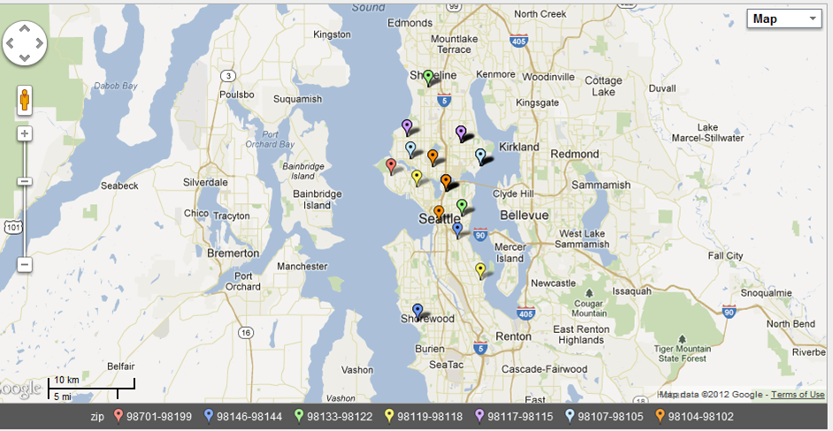
Figure 27 Henry visitors’ zip codes from the pilot test.
The figure above is the plot of zip codes taken from respondents during the pilot test. Of the 34 zip codes collected only one person was from the suburbs of Seattle. The mode of this data was also 98102, the Eastlake / Capitol Hill neighborhood of Seattle.
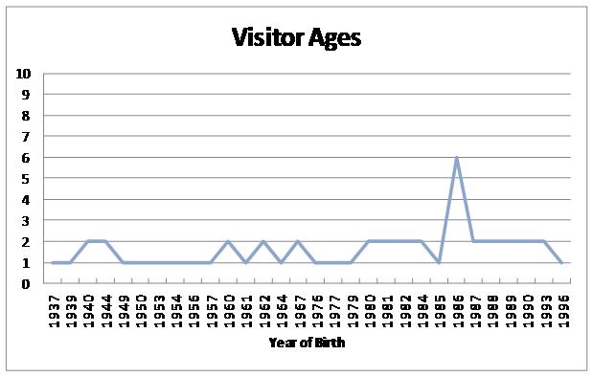
Figure 28 Visitor ages

In order to get a better picture of who is coming to the Henry, we also inquired about visitor ages. In the pilot test, we asked respondent to indicate which age group they belonged to; however, nine age brackets proved to be too cumbersome and in our actual instrument, we asked for the visitors’ year of birth. the average year was 1972, or 40 years old. The most common response was 1986, or 25-26, and the range of ages was 59 years.
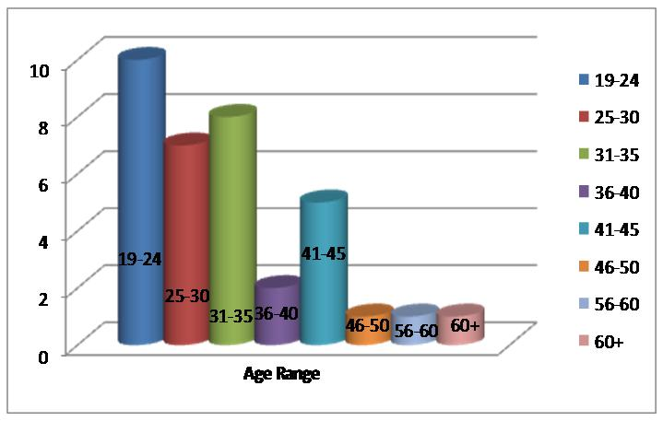
Figure 29 Age ranges during the pilot test

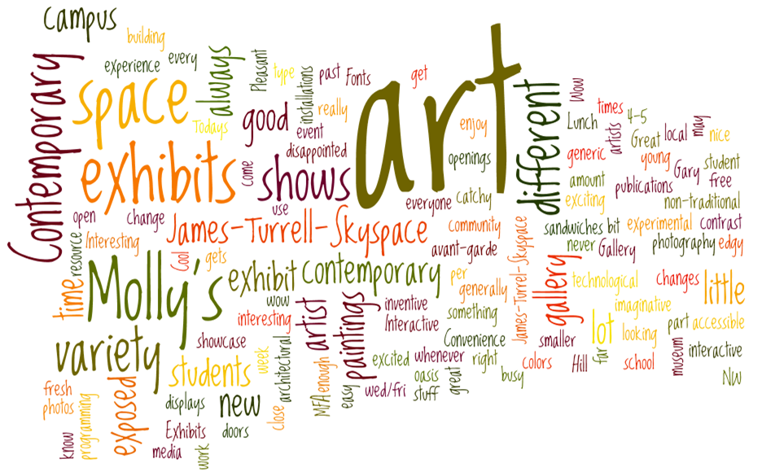
Figure 30. What excites you about the Henry? Wordle
The Henry views itself to be a unique art institution in Seattle but desired to know if that is the way that the audience also felt about it. In order to ascertain if visitors genuinely regard the Henry as different without implying that it was through a leading question, we developed the question, “what excites you about the Henry?” in an attempt to elucidate whether or not visitors feel that way. This question did precisely that. Of the 45 people who responded to this question, 12 (27%) of them cited the “experimental,” “non-traditional,” “avant-garde,” and other similar adjectives as what excites them most. Other frequently cited answers were the art (8 people), without such emotive adjectives, the variety / changing of exhibitions (8 people), and Molly’s. The other answers are as follows:
Accessibility, on campus, local - 4 people
Space / building - 4 people
Skyspace - 3 people
Interactive - 2 people
Openings / Programming - 2 people
Student work - 2 people
Multimedia - 1 people
Graphic Design - 1 people
Free - 1 people

The pilot test version of this question was: “what would you tell a friend about the Henry?” See figure 31 below for the wordle of those responses.
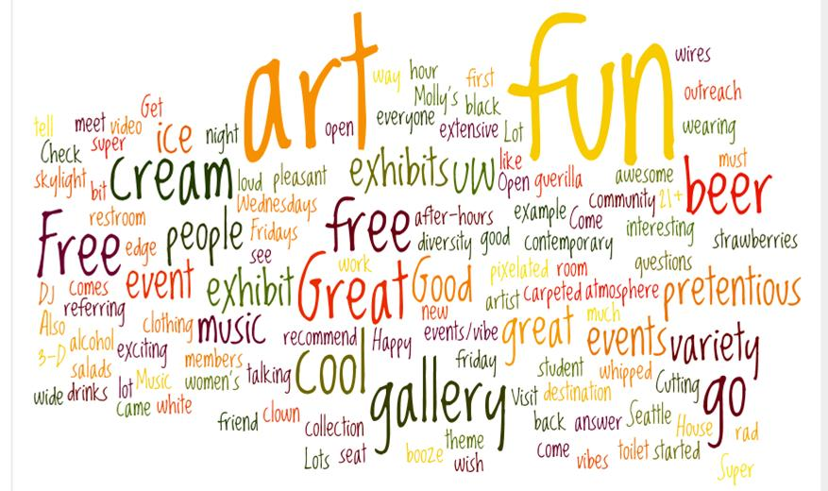
Figure 31 - What would you tell a friend about the Henry Wordle.

We also wanted to know what expectations visitors had for their visit to the Henry and if the Henry met those expectations. This ended up being the most awkward question on the survey with 28 people not answering or having no expectations. Of the 23 people who actually expressed expectations, 5 people did not respond to the follow up. Of the responses, the average was 8.6, with a range from 5 to 10, with the mode being a 10. Gary Hill, the friendliness of the staff, and Molly's were the most frequently cited as to why their expectations were met.

Discussion:
According to our data, Wednesday, Thursday and Fridays have the highest numbers of visitors in the building, although 30% are only there to get coffee or lunch at the café. Many visitors stated they have come to Molly’s 5 or more times in the past year. This is proportionate to the number of visitors who are visiting the galleries at the Henry. A limitation to collecting more evaluations from individuals who are visiting the museum galleries and not the café is that during the week when visitation numbers are higher the café is open at the same time as the museum. Another limitation was the placement of the evaluator at near the DIG where the evaluator encountered many visitors coming up the stairwell who had only been to the café.

Limitations of methodology and the implementation of evaluation:
Due to the brief period of data collection, we were only able to survey a total of 103 people. As the Henry Art Gallery sees many more visitors than this, the data may not represent the entire population of visitors. As stated in our findings, many visitors were at the museum exclusively for the cafe and declined to take the survey, even if they may come to the museum to see art at other times.

Conclusion:
The Henry Art Gallery has a potential museum audience who are already in the building for Molly’s, staff should pilot test strategies to draw café visitors into the museum galleries. Future research could be conducted in the café to find out why patrons of Molly’s do not visit the galleries and what types of marketing and perhaps even programs or exhibits would attract these audiences.

Acknowledgements:
We would like to thank Nick Visscher for his guidance and advice throughout the evaluation. We are very grateful to the Henry Staff for their receptivity and support throughout our project. A special thanks goes out to Betsey Brock, Rachael Faust, and Whitney Ford-Terry for their willingness to participate and collaborate on an audience research project.

References:
Henry, C. (2000). How Visitors Relate to Museum Experiences: An Analysis of Positive and
Negative Reactions. The Journal of Aesthetic Education, 34(2), 99-106.

Korn, Randi, & Associates, Inc, (2008). Young Adult Study. Boston, MA: Isabella Stewart Gardner Museum of Art.

Preskill, H. (2011). Museum Evaluation without Borders: Four Imperatives for Making Museum Evaluation More Relevant, Credible, and Useful. Curator, 54(1), 93-100.

Appendix
A. Direct Quotes from Visitors
During the Open House
I would tell a friend...
“Check out the skylight room if you go”
“ It was so much fun!”
“It’s a cool art gallery and would recommend it to a friend”
“ Great art in a pleasant atmosphere”
“Lots of fun! Good ice cream, music, drinks, what a great event”
“The music is far too loud”
“It’s awesome!!!!”
“I would tell them there is a wide variety of art and people are open to answer
questions”
“This exhibit [Gary Hill] is pretentious”
During the 1st Thursday Event
“I will encourage my friends to come”
“I’m surprised more people aren’t here right now”
“I used the DIG but didn’t think it worked very well”

During Regular Hours
“I’m not really interested in pottery”
“I was pleased with what I saw”
“The staff are nice and helpful”
“The building is a good place to showcase art”
“The exhibitions are always really inventive”
“They’re going to open their doors to an artist no other museum would”
“I like that it is on campus”
“It’s a different experience every time”
“I like the art openings and it’s free for students. That’s nice.”
“Exhibits have been exciting in past -- not so much today”
“Today’s exhibits were not too exciting”
“[The Henry is] the most interesting gallery in the Northwest”

B. Evaluation Instrument

