Visitor Engagement of Research Highlight and Evolution Wall Exhibits

Burke Natural History Museum

University of Washington

May 30, 2012

Amy Dygert
Ari Einbinder
Dylan High

Table of Contents

Title Page……………………………………………………………………………………………..1
Executive Summary……………………………………………………………………………..3
- Introduction…………………………………………………………………………………………4
Background…………………………………………………………………………………..4
Application…………………………………………………………………………………….5
New Directions……………………………………………………………………………….5
Evaluation Questions…………………………………………………………………….6
- Literature Review…………………………………………………………………………………7
- Methods ………………………………………………………………………………………………8
- Results………………………………………………………………………………………………….11
- Discussion…………………………………………………………………………………………….21
- Conclusion……………………………………………………………………………………………23
- Acknowledgements……………………………………………………………………………..25
- References…………………………………………………………………………………………..26
- Appendix……………………………………………………………………………………………..27
Copy of final instrument………………………………………………………………..27

Diagram of Evolution Wall……………………………………………………………..29

Photograph of Evolution Wall………………………………………………………..30

Diagram of Research Highlight……………………………………………………….31

Photograph of Research Highlight………………………………………………….32

Additional Crosstabulations of Data……………………………………………….33

Executive Summary

Purpose:
To determine the effectiveness of the Evolution Wall and Research Highlight exhibit in conveying the main topics of the exhibit: biodiversity and the research of Burke curators

Evaluation Questions:
- What is the nature of Evolution Wall and Research Highlight use by visitors? What draws their attention?
- Do visitors understand that the exhibit is about evolution and biodiversity?
- To what extent are visitors aware that Burke curators are involved with and conduct current research?

Key Findings:
- The Evolution Wall and the photos were the most interesting components of exhibit for visitors
- Most visitors did identify the main topic as either “evolution” or some aspect of biodiversity
- Most visitors did not consider research a part of a curator’s job
- Most visitors are interested in learning about the research done by Burke curators

- INTRODUCTION

Background
The Burke Museum is a natural history museum in Seattle, Washington. It is a university museum on the campus of the University of Washington, and is the natural history museum for the state of Washington. It includes research and collections in arachnology, archaeology, botany, ethnology, geology, herpetology, ichthyology, malacology, mammalogy, ornithology, and paleontology. As a result of its connection to the university, the museum features research conducted by faculty from the University of Washington, especially those faculty members who are also curators of the Burke Museum.
The Museum has created a new exhibit entitled “Why Study Evolution?” featuring research by Museum curators. The exhibit contains an artistic rendering of a phylogenetic tree and a Research Highlight featuring the work of herbarium curator Dick Olmstead. It focuses on his study of plants in the verbena family, emphasizing his research process and how his findings support and elucidate the different evolutionary processes that lead to biodiversity.
The Burke Museum attracts a wide audience both from within the University and outside, bringing in groups of pre-K through 12th grade students, university students, and adults. The content of the Research Highlight, however, is geared toward visitors with some prior knowledge of evolution, biology, and scientific research. While the Research Highlight is designed to provide higher level information to those knowledgeable about the content discussed in the exhibit, the Research Highlight is also meant to inform general visitors about some of the research that is currently being undertaken by museum curators.
The space for this exhibit is at either the beginning or the conclusion of the Life and Times exhibit, depending on which way the visitor chooses to begin. The exhibit is located on the main floor of the Burke Museum. There are two components which we are evaluating: Firstly, an artistic rendition of an evolutionary tree, which includes some basic information on biodiversity and common descent; and secondly, to its right, the Research Highlight, which is about the evolution of the verbena family of plants, and includes photos, text, samples of plants, video, and QR codes which link to additional information. The space is in a main corridor, and it connects the Life and Times exhibit exit to the lobby.

APPLICATION
As the Burke Museum prepares for a new building and a move into that new facility, their exhibition staff would like to evaluate the effectiveness of its current exhibits. In particular, the museum would like to understand the effectiveness of displays such as the Research Highlight in sharing with the public the research being conducted by university and museum faculty. As the Burke would like to create new ways of sharing its research with the public, this exhibit space will be an opportunity for the Burke to learn about the public’s interest in that research and which methods are most effective for engaging the public. Finally, the exhibit is funded by grant money from the National Science Foundation—money that was awarded for the dissemination of research. Thus, the exhibit is an integral part of the research grant, with the goal of extending the impact the research has to a greater audience.
Our findings in this project will inform the design of two additional displays, discussing other research initiatives of the museum’s curators. There is also the possibility of minor remedial changes being made to the research case we are evaluating. Therefore, this project is summative.
In the field at large, the results of this evaluation will aid in the development of exhibits for museums (particularly university museums) and other research-based institutions that wish to convey their findings in way that is both technical and useful for experts in the field, but also accessible and interesting for the general public. Through this evaluation, our team aims to assist the Burke and similar institutions in developing exhibits that convey complex messages to a diverse audience—in this case, to those with a high level of knowledge and understanding of botany and evolutionary processes, as well as to those will little background knowledge in these fields.

New Directions, University of Washington
This study was conducted by three Master’s candidates in the Museology program of the University of Washington. The study was done as part of a for-credit academic course, as well as part of the program’s New Directions project:
"New Directions is an IMLS funded project designed to train museum studies graduate students to understand, support and engage in audience research. A key component of the training is using museums as learning laboratories where students work with an institution to conduct audience research, under the guidance of evaluation mentors and support staff. "

Evaluation Questions
- What is the nature of Evolution Wall and Research Highlight use by visitors? What draws their attention?
- Do visitors understand that the exhibit is about evolution and biodiversity?
- To what extent are visitors aware that Burke curators are involved with and conduct current research? Does the exhibit impact this?

In developing the evaluation questions above, we assessed a set of impact statements for the exhibition. This was done on our part to better formulate the intentions of the Burke team in designing the exhibit and helped inform our instrument development. The impact statements we identified for the Evolution Wall and Research Highlight exhibit include:

- Visitors will be aware of the research being conducted by curators the Burke.
- Visitors will show interest in the botanical research on evolution presented in the exhibit.
- Visitors will make use of the components in the exhibit.
- Visitors will understand the main concept of the exhibit as evolution and/or biodiversity.

- LITERATURE REVIEW

In preparation for this study, our team reviewed instructional materials about research and instrument design, visitor perception and participation, and other evaluation tools. The first source we utilized was Practical Evaluation Guide: Tools for Museums and Other Informal Educational Settings (1999), written by Judy Diamond, Jessica J. Luke, and David H. Uttal. This text examines the steps of the evaluation process (including instrument design, data collection, and data analysis). The focus of the text is on evaluation of informal learning settings. This text was useful preparation for evaluation study and development, and was specifically applicable to our study in an informal learning environment.
A second text we utilized in our study is titled, Designing and Constructing Instruments for Social Research and Evaluation (2007), by David Colten and Robert Covert. This text maintains a more specific focus on creating evaluation instruments that yield reliable and valid results. We found particularly helpful its discussion on the use and crafting of open-ended questions in a study. Furthermore, the text emphasized the importance of crafting an instrument based on the reliability and validity of the results.
A final text we consulted in our work was Identity and the Museum Visitor Experience (2009), authored by John Falk. This text focused on the visitor experience and perspective, which we attempted to keep in mind at all times when preparing the instrument and collecting our data. The text also provided some best practices and theory of visitor studies.

- METHODS

Timeline
- 4/9: Submit evaluation plan
- 4/14: Draft of instruments
- 4/20: Submit instruments
- 5/5-5/20: Data collection
- 5/20-5/25: Data analysis
- 5/23-5/27: Draft of final report
- 5/27-5/28: Develop presentation
- 5/6: Present findings to client & New Directions
- 5/8: Submit final report

Study Participants
While the exhibit as a whole is intended for the general audience of the Burke Museum, the two pieces we studied—the Evolution Wall and the Research Highlight—targeted separate audiences. The Evolution Wall, which included an artistic rendering of a phylogenic tree, was intended for a visitor with a wide range of familiarity with the topic. It includes explanatory panels with a large amount of text, however the diagram is made so that it can be “read” without other written explanation. While the Evolution Wall is for any visitor, the Research Highlight is intended to interest specifically museum visitors that have an academic background in Biology or a similar life science.
In our study, we decided to use convenience sampling in an effort to maximize the number of participants. Given the purpose of the Research Highlight display, we decided to only interview adult visitors. Furthermore, we only sought interviews with visitors that at least paused at both exhibits of their own initiative. We also sought casual visitors (those not a part of a school or other group).
We began with a goal sampling size of thirty participants. Within the time limitations of our work, we were able to record 28 interviews.

Method: Semi Structured Interview
We selected a semi-structured interview for this study, as it allowed us to collect a combination of quantitative data (i.e. demographic) and qualitative data (i.e. exhibit experience). This also was a method that achieved a balance of reaching as many visitors as possible while still addressing the extent of the visit’s experience. An example coding chart for open-ended questions follow the instrument questions.

Open-Ended Questions
- Of the components you see in this exhibit, what was the most interesting to you? Where did you spend most of your time?
- Briefly, how would you describe the main topic of the exhibit?
- Describe what you think the job of the Burke museum’s curators involves. What do you think is in their job description?
- How did this change after seeing the exhibit, if at all?
- Before seeing this exhibit, were you aware that the curators at the Burke Museum also conduct research?

Ratings (1=low, 8=high)
- On a scale of 1-8, please rate your understanding of biodiversity prior to seeing this exhibit.
- On a scale of 1-8, how personally significant did you find the information in the exhibit?
- On a scale of 1-8, please describe your interest in learning more about research being conducted by curators at the Burke Museum.

Demographic Information
- In what year were born?
- [Educational Background (i.e. degrees and areas of focus)]
- How often have you visited the Burke Museum in the past two years?

Coding
The answers to the open-ended questions at the beginning of the survey were coded by the evaluation team to reflect common responses. These responses could be coded into multiple categories. Examples of responses and their associated coded categories are shown below.
Example Chart
 | Quote | Coded As…
Of the components you see in this exhibit, what was the most interesting to you? Where did you spend most of your time? | The QR Codes- I use them in business, I work for a company that put together these kinds of things...The evolution tree is well laid out...The research highlight is better for high school kids and up, but is not easy to explain to kids... I would put the pictures below so that kids could see them easier. | QR Codes; Evolution Tree
 | The Tree of Life visual, because it is easy to read and navigate. It is simple, and easy to take it in. The other (gesturing towards the Research Highlight) is a bit overwhelming. | Evolution Tree
 | The tree..the different branches/different species and how they intertwine. I liked the color photographs, especially the shapes of the flowers-I am a gardener, so that attracted me. | Evolution Tree; Photos
Briefly, how would you describe the main topic of the exhibit? | It is an informative description of evolution and plant life. It also talks about plant DNA...The exhibit displays field research. | Evolution; Botany; Field Research; DNA
 | evolution, different plants and species are in different locations; diversity of plant life | Evolution; Biodiversity
 | Rare plants in Argentina | Botany
Describe what you think the job of the Burke museum’s curators involves. What do you think is in their job description? | They explain certain things with artifacts, with a limit of what they can show | Assemble and Maintain Exhibits; Interpretation/ Education
 | 1. provide info & explanation for exhibit to public. 2. care for and maintain materials. 3. they're the go-to people to find out about studying stuff here. | Interpretation/Education; Maintain Collections; Other
 | Their job is to convey or explain a field of study and attract people to it. They highlight the best points. They have to find objects. I tend to think of art and curators at art museums, where is less text. | Assemble and Maintain Exhibits; Interpretation/Education; Other

- RESULTS

- Evaluation Question 1: What is the nature of Evolution Wall and Research Highlight use by visitors? What draws their attention?
In our first open-ended interview question, we asked visitors what components they liked in the exhibit. The most common response was the Tree of Life diagram from the Evolution Wall, with 18 out of 28 respondents claiming this was of interest. This was followed by photos, with 8 out of 28 respondents claiming the color photographs drew their attention.

Interest Frequencies
What components were you interested in? |  | Responses |  | Percent of Cases
 |  | N | Percent
 | QR Codes | 1 | 2.6% | 3.6%
 | Tree of Life | 18 | 46.2% | 64.3%
 | Text Panels | 4 | 10.3% | 14.3%
 | Specimens | 6 | 15.4% | 21.4%
 | Video | 2 | 5.1% | 7.1%
 | Photos | 8 | 20.5% | 28.6%
Total |  | 39 | 100.0% | 139.3%
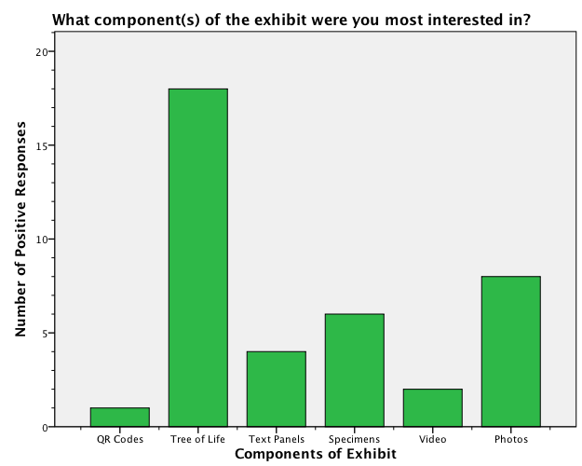

- Evaluation Question 2: Do visitors understand that the exhibit is about evolution and biodiversity?
In our second open-ended question, we asked visitors what they thought the main topic of the exhibit was about. The most typical response was “evolution,” with 14 out of 28 respondents mentioning this in their answers. However, many respondents also mentioned aspects of biodiversity in their answer. 7 out of 28 respondents mentioned biodiversity or diversity of life explicitly in their answer. However, a number of respondents also mentioned some aspect of biodiversity in their answer, such as adaptation, migration, or “life is related.” This shows that many visitors were able to identity the intended main messages in the exhibit. However, significantly only 1 respondent mentioned that the exhibit was about field research.
Topic Frequencies
What is the main topic of the exhibit? |  | Responses |  | Percent of Cases
 |  | N | Percent
 | Evolution | 14 | 26.4% | 51.9%
 | Biodiversity | 7 | 13.2% | 25.9%
 | Botany | 13 | 24.5% | 48.1%
 | Field Research | 1 | 1.9% | 3.7%
 | Life is Related | 5 | 9.4% | 18.5%
 | Importance of Life | 2 | 3.8% | 7.4%
 | DNA | 2 | 3.8% | 7.4%
 | Migration | 5 | 9.4% | 18.5%
 | Adaptation | 2 | 3.8% | 7.4%
 | Education | 1 | 1.9% | 3.7%
 | Unsure | 1 | 1.9% | 3.7%
Total |  | 53 | 100.0% | 196.3%

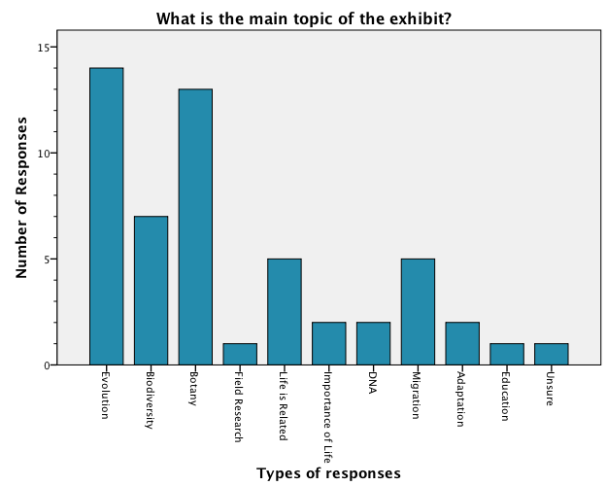
- Evaluation Question 3: To what extent are visitors aware that Burke curators are involved with and conduct current research?
Finally, our last open-ended question asked visitors what they believed the job of a curator at the Burke Museum entails. Significantly, only 1 respondent mentioned research in their responses.

Curator Frequencies
What is the job of a curator? |  | Responses |  | Percent of Cases
 |  | N | Percent
 | Research | 1 | 1.9% | 3.6%
 | Assemble and Maintain Exhibits | 21 | 40.4% | 75.0%
 | Interpretation/Education | 15 | 28.8% | 53.6%
 | Maintain Collections | 4 | 7.7% | 14.3%
 | Other | 11 | 21.2% | 39.3%
Total |  | 52 | 100.0% | 185.7%
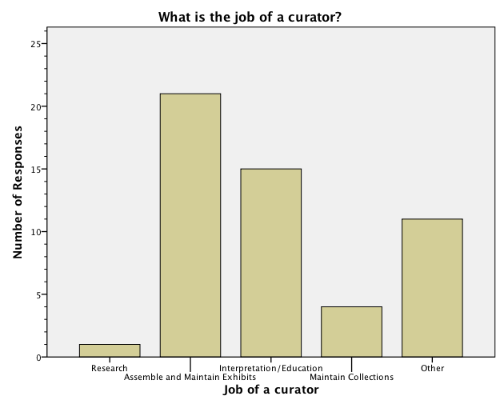

- Other
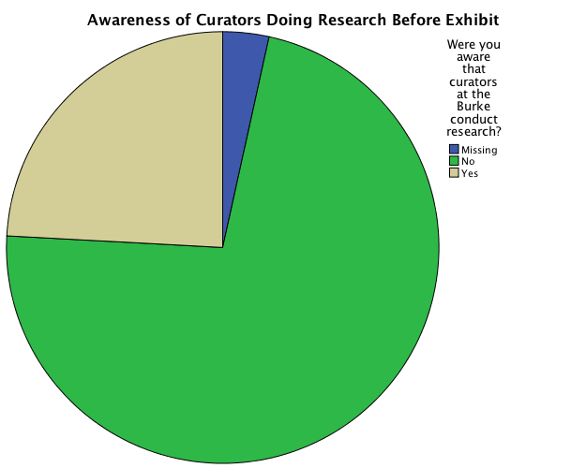

Were you aware that curators at the Burke conduct research?
 |  | Frequency | Percent
Valid | No | 21 | 72.4
 | Yes | 7 | 24.1
 | Total | 28 | 96.6
Missing | Non-response | 1 | 3.4
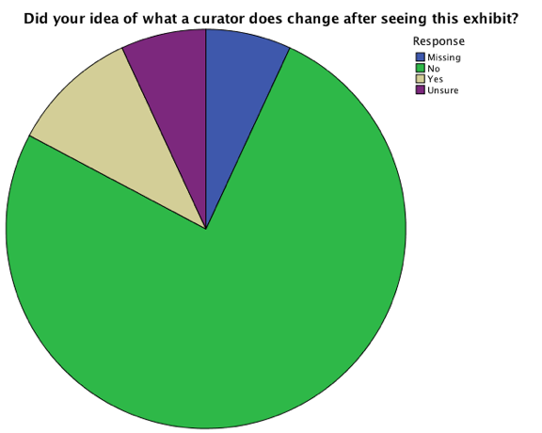

Did your idea of what a curator does change after seeing the exhibit?
 |  | Frequency | Percent
Valid | No | 22 | 75.9
 | Yes | 3 | 10.3
 | Unsure | 2 | 6.9
 | Total | 27 | 93.1
Missing | Non-response | 2 | 6.9
Total |  | 29 | 100.0

Significantly, very few people mentioned that their idea of what a curator does changed after seeing this exhibit. Only 3 out of 27 responses said that they believed their idea of what a curator does changed after seeing the exhibit.

One of our scale questions was to ask visitors about their previous understanding of biodiversity before seeing the exhibit. Most respondents rated themselves in the middle to high ranges, with the most number of respondents answering 8 (with 1 being low understanding and 8 being high level of understanding).
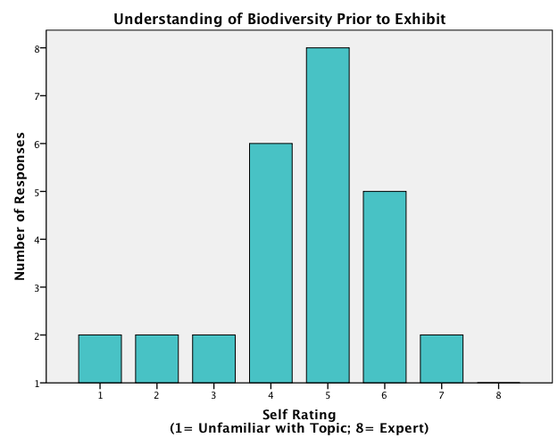
Our second rating question asked visitors to rate how personally significant they found the information in the exhibit. Here, there was a wide spread with no significant trends.

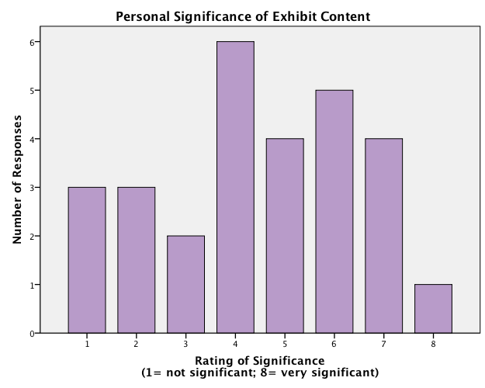

Finally, our last rating question asked visitors to describe their interest in learning more about the research being conducted by Burke curators. Here, many respondents rated themselves higher on the scale, with most respondents rating their interest as 6 or above.
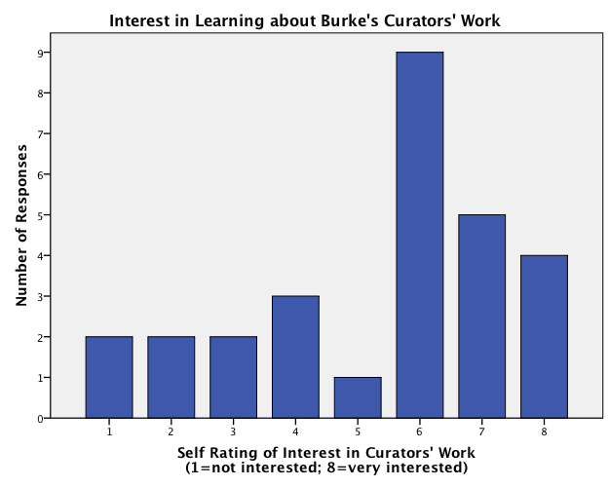

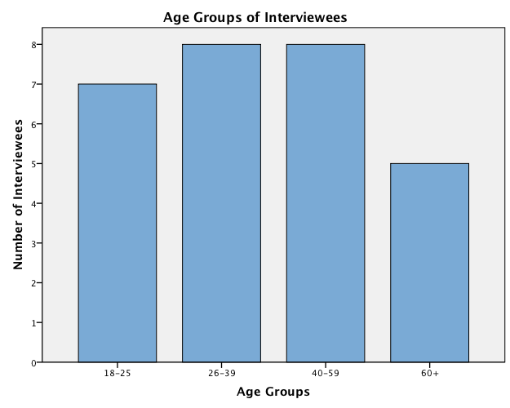
We have a fairly large spread in the ages represented in our sample. Above, you can see the distribution of age groups in our sample. Therefore, it would seem that the exhibit is able to capture the attention of all ages of adult visitors.
Age Groups
 |  | Frequency | Percent
Valid | 18-25 | 7 | 24.1
 | 26-39 | 8 | 27.6
 | 40-59 | 8 | 27.6
 | 60+ | 5 | 17.2
 | Total | 28 | 96.6
Missing | Non-response | 1 | 3.4

Education
 | Biology/Life Science Major | Other Major | Total
Associate's/ Some Bachelor's | 1 | 10 | 11
Bachelor's | 1 | 7 | 8
Master's or some Post-Graduate | 3 | 4 | 7
Doctorate (Completed) | 1 | 1 | 2
Non-Response |  |  | 1
Total | 6 | 22 | 29

Overall, we have few respondents who had a background in biology or the life sciences, with only 6 respondents who mentioned that they had an educational background in these fields. This is useful in determining the audience of the exhibit-which is not necessarily visitors’ with a high level of knowledge about the topic, but rather attracts visitors from a variety of different academic backgrounds.

How many times have you visited the Burke in the past 2 years?
 |  | Frequency | Percent
Valid | 1-2 | 25 | 86.2
 | 3-4 | 3 | 10.3
 | Total | 28 | 96.6
Missing | non-response | 1 | 3.4
Total |  | 29 | 100.0

- DISCUSSION

Importance & Relevance of Results

With the data we collected, we believe that the key takeaways for the Burke museum are that, 1) Most visitors understand the main topic of the exhibit to be evolution or something similar (i.e. biodiversity), and 2) that most did not take away from the exhibit any new information about curatorial work of curatorial research.
As noted in the graphs of visitor responses about the exhibit’s main topic, the majority of responses center on evolution, biodiversity, or a specific concept of evolution (life is related, DNA, migration, or adaptation). As we looked for correlations between the main topic and education level or the main topic and demographic information, we found that such correlations were not heavily present in our sampling. Where correlations were found, they are somewhat suspect due to small sample size.
Within people noting this as the main topic, however, we did find that some interviewees with a strong academic background in biology or life sciences would draw much more specific information from the exhibit. For example, when asked about the exhibit’s main topic, a science educator articulated, “It basically follows Darwin's path- it goes from the generalized to the concrete parts of evolution. It starts from the generalized and then goes to plants.” Another participant who was a doctoral candidate in molecular biology, described the main topic as, “Rare plants in Argentina.”
While the majority of visitors identified the broad concept of evolution or a related concept as the main topic, some articulated much more specific responses than others. Further research could be done to determine a direct correlation between academic knowledge of the subject matter and different levels of understanding of exhibit’s presented concepts.
Transitioning to the exhibit’s message about curatorial research, we noted that few included research in their job description of a curator at the Burke museum. We also found that few people were aware of this after viewing the exhibit. Lastly, it is noteworthy that no study participants mentioned curatorial research as the main topic of the exhibit. While few noted research as an aspect of a curator’s job, however, a majority of participants indicated a moderate to high level of interest in learning about current research the curators are conducting. This suggests that visitors, even those who stop at the exhibit, do not catch that the Research Highlight is communicating information about current curatorial research. For example, when asked what about his awareness of a curatorial research, one visitor commented, “No, honestly, I was not thinking about the curator.” With this same question, another visitor commented, “Yes, but I learned that from the collections to the side (pointing to small collection cabinets in the corner); I did not get that from the exhibit.” In fact, when asked about the position of a curator at the Burke Museum in our interview, many visitors remarked that they had not considered a curator’s job when looking at the exhibit, or anytime before.

Limitations of Methodology and Implementation

We would like to note a couple of limitations in our work, to be considered by both the Burke staff using this report and anyone performing evaluations in the future of this space. The most noticeable limitation or challenge we encountered was time. As this was done as a part of a class project, there were very specific beginning and ending dates for our project, which led to a somewhat limited time for data collection. Data collection also needed to be done in coordination with events and other programs at the Burke museum. While we are happy with this sample size for our study, such a small number makes it difficult to identify correlations in our data and for any correlations present to be statistically significant. For example, we were interested in finding whether there was a correlation between education level and the components of interest in the exhibit, and were unable to find one. It is unclear if this is a valid result or if a greater sample size would yield a correlation.
Another limitation that affects our work is our beginner-status with SPSS, which we used to analyze our data. While we do not suggest that our data analysis is flawed, we do acknowledge that having a better understanding of the SPSS system when first creating the instrument would have been beneficial. Such knowledge would have yielded slightly different instrument questions that would in turn have led to more conclusive data.

- CONCLUSION

Suggestions & Implications for Project Site

Based on our findings, we have both remedial suggestions for the current Research Highlight and suggestions for future Research Highlight displays. These are based on the data we analyzed and our conversations with visitors about their experiences in the museum and this exhibit in particular.
If the Burke is willing to make a remedial change to the current exhibit, we conclude making the main point and/or objective of the displays more explicit to visitors would be helpful. For example, if the primary purpose of the exhibit is to communicate that Burke curators conduct research, a title about curatorial research could effectively frame the visitor’s exhibit experience. Another suggestion, again dependent on if the exhibit’s main purpose is to communicate curatorial research, would be to more closely link the exhibit with the small collections on display in the nearby corner.
For future Research Highlight exhibits, we believe the data suggests: 1) it would be beneficial to cue visitors that the exhibit communicates a curator’s participation in research, and 2)continue to include (and possibly increase) a range of familiar and unintimidating elements in the exhibit.
Opportunities for Future Research

In conducting this evaluation, we have noted a few possibilities for future research. As we gathered background information on the Burke Museum, exhibit staff commented that the Museum planned to add more Research Highlights in the area of the current Research Highlight display. As this is done, we would recommend continued evaluation of these new exhibits, with particular attention paid to their location relative to other exhibits (such as whether visitors are “eased” into these more in-depth exhibits and how that particular location, as a fairly narrow corridor, may effect visitors’ comfort in stopping to engage the exhibit).
Aside from future exhibits, further study could be done with the current exhibit. For example, more in-depth interviews and/or focus groups would be useful methodologies. These could help staff better understand what visitors consider as the curator’s role and thereby aid in devising better ways to communicate that Burke curators conduct research. Lastly, we would recommend a study that tracks the percent of visitors who stop at the exhibit. This could better inform the Burke which visitor types these exhibits attract, if there are specific groups, and which elements, objectively viewing, seem to capture visitors’ attention and interest.

- Acknowledgements

We would like to thank the staff at the Burke Museum for their support and assistance throughout this project. In particular, we would like to thank Erin Younger, director of exhibits, for her input on our evaluation plan, coordinating our schedules with those of the Burke Museum, and discussing with us the priorities of the Burke Museum and its vision for the future. Similarly, we would like to thank Dick Olmstead, curator of the Research Highlight evaluated in our study, for his input on our evaluation plan. Lastly, we are greatly appreciative of Sarah Tollefson and the Visitor services team at the museum for their assistance and flexibility.
In addition to museum staff, we would like to thank Emily Craig, Research Associate at the Institution for Learning Innovation and New Directions alum, for her input on our evaluation plan and instrument development. We also thank Fred Nick, Director of CSSCR at the University of Washington, for his introduction to SPSS.
Finally, we would like to thank the staff and faculty associated with the New Directions initiative at the University of Washington. We are grateful for the feedback and critiques we received from fellow students, and the collaborative efforts throughout the program. Special thanks to Nick Visscher to his guidance, feedback, organization, and undying optimism as we completed our project.

- References:

Diamond, Judy, Jessica J. Luke, and David H. Uttal. Practical Evaluation Guide: Tools for Museums and Other Informal Educational Settings. Lanham, MA: AltaMira Press, 1999.
Colten, David and Robert Covert. Designing and Constructing Instruments for Social Research and Evaluation. San Francisco, CA: Jossey-Bass, 2007.
Falk, John. Identity and the Museum Visitor Experience. Walnut Creek, CA: Left Coast Press, 2009.

Appendix A: Instrument, Side 1

Date: ______________ Instrument #: ______________
Time: ______________ Data Collector: ______________
● Of the components you see in this exhibit, what was the most interesting to you? Where did you spend most of your time? (i.e. reading the text, watching the video, looking at the photographs, looking at the specimens, or studying the tree of life)
● Briefly, how would you describe the main topic of the exhibit? (PROBE: What did you learn from the exhibit?)
● Describe what you think the job of the Burke museum’s curators involves. What do you think is in their job description? (NOTE: Just interested if they mention ‘research’ in their description)
● How did this change after seeing the exhibit, if at all?
● Before seeing this exhibit [gesture towards exhibit], were you aware that the curators at the Burke Museum also conduct research?
Appendix A: Instrument, side 2

1.) On a scale of 1-8, please rate your understanding of biodiversity prior to seeing this exhibit. (Circle one):
1 2 3 4 5 6 7 8
2.) On a scale from 1-8, how personally significant did you find the information in this exhibit? (Circle one):
1 2 3 4 5 6 7 8
3.) On a scale of 1-8, please describe your interest in learning more about research being conducted by curators at the Burke Museum. (Circle one):
1 2 3 4 5 6 7 8
4.) In what year were you born? ___________________________
5.) Education completed. If currently enrolled in any of the listed programs, include expected graduation date in the margins of the page.
 | YES | NO | Areas of Study/Interest:
High School Diploma
Associate’s Degree
Bachelor’s Degree
Master’s Degree
Doctorate
Trade School/Certificate Program
Other
7.) How often have you visited the Burke Museum in the past two years?
1-2______
3-4______
5+ ______
8.) (DATA COLLECTOR): Visitor observed-
_____ Research Highlight
_____ Evolution Wall

Appendix B: Diagram of Evolution Wall

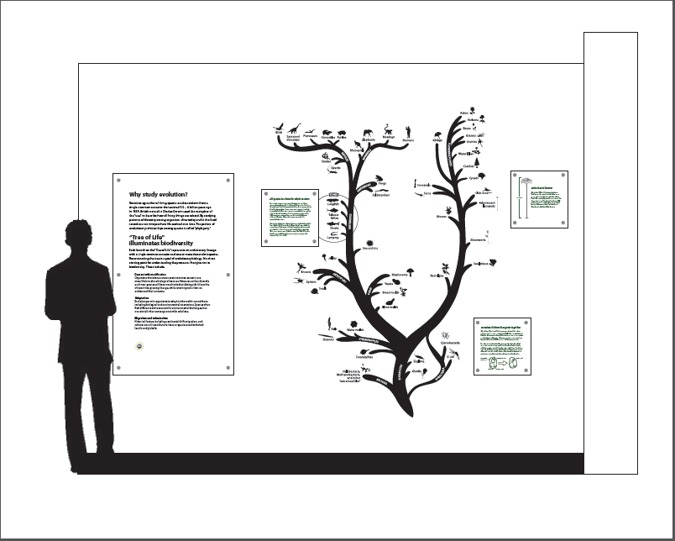

Appendix C: Photograph of Evolution Wall

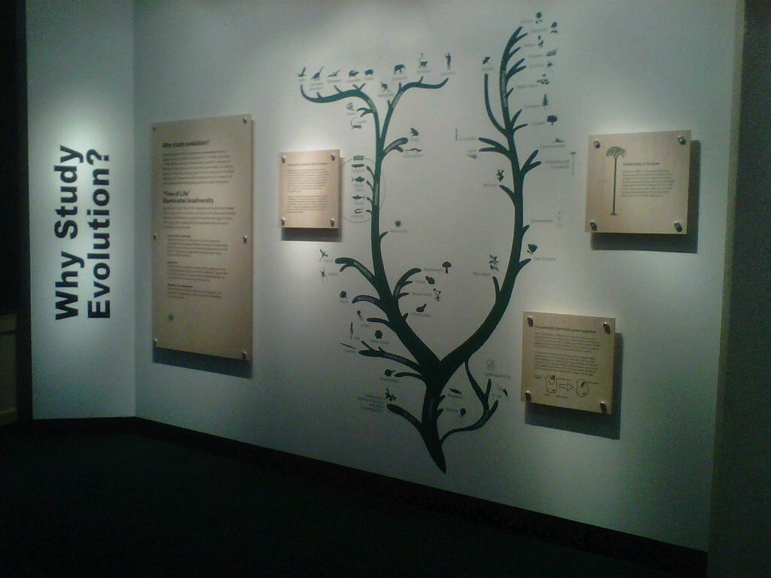

Appendix D: Diagram of Research Highlight

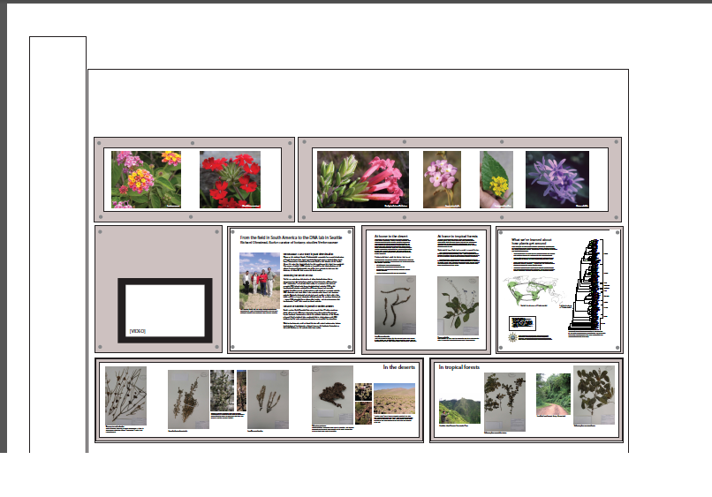

Appendix E: Photograph of Research Highlight

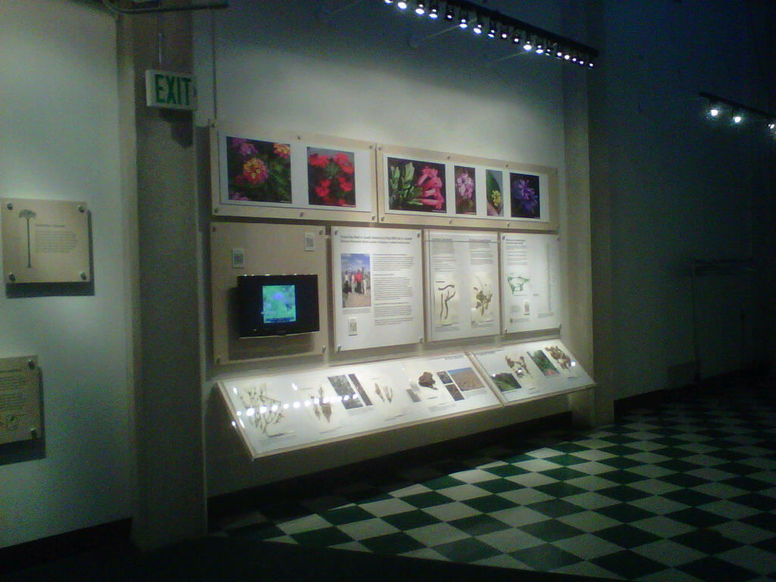

Appendix E: Additional Crosstabulations
Crosstabulation of Main Topic Question and Understanding of Biodiversity Rating
What is the Main Topic of the Exhibit? |  |  | Grouped rating of understanding of biodiversity |  |  | Total
 |  |  | 1-3 rating | 4-5 rating | 6-8 rating
 | Evolution | Count | 2 | 8 | 4 | 14
 | Biodiversity | Count | 1 | 2 | 4 | 7
 | Botany | Count | 3 | 5 | 5 | 13
 | Field Research | Count | 0 | 1 | 0 | 1
 | Life is Related | Count | 1 | 3 | 1 | 5
 | Importance | Count | 1 | 0 | 1 | 2
 | DNA | Count | 0 | 1 | 1 | 2
 | Migration | Count | 0 | 2 | 3 | 5
 | Adaptation | Count | 1 | 1 | 0 | 2
 | Education | Count | 0 | 1 | 0 | 1
 | Unsure | Count | 0 | 1 | 0 | 1
Total |  | Count | 9 | 25 | 19 | 53

Crosstabulation of Interest and Age Groups
What Components were You Interested In? |  |  | Age Groups |  |  |  | Total
 |  |  | 18-25 | 26-39 | 40-59 | 60+
 | QR Codes | Count | 0 | 0 | 1 | 0 | 1
 | Tree of Life | Count | 3 | 4 | 8 | 3 | 18
 | Text Panels | Count | 1 | 0 | 2 | 1 | 4
 | Specimens | Count | 3 | 2 | 1 | 0 | 6
 | Video | Count | 0 | 1 | 0 | 1 | 2
 | Photos | Count | 3 | 3 | 0 | 2 | 8
Total |  | Count | 10 | 10 | 12 | 7 | 39

Interest* Topic Crosstabulation
Components of Interest |  |  | Main topic of the exhibitª |  |  |  |  |  |  |  |  |  |  | Total
 |  |  | Evolution | Biodiversity | Botany | Field Research | Life is Related | Importance | DNA | Migration | Adaptation | Education | Unsure
 | QR Codes |  | 1 | 0 | 1 | 1 | 0 | 0 | 1 | 0 | 0 | 0 | 0 | 1
 | Tree of Life |  | 12 | 5 | 7 | 1 | 3 | 2 | 2 | 3 | 1 | 1 | 0 | 18
 | Text Panels |  | 3 | 1 | 3 | 0 | 0 | 0 | 1 | 2 | 0 | 0 | 0 | 4
 | Specimens |  | 2 | 1 | 3 | 0 | 2 | 0 | 0 | 2 | 0 | 0 | 0 | 5
 | Video |  | 1 | 0 | 1 | 0 | 0 | 0 | 0 | 0 | 0 | 0 | 0 | 2
 | Photos |  | 3 | 3 | 5 | 0 | 1 | 0 | 0 | 3 | 2 | 0 | 1 | 8
Total |  |  | 14 | 7 | 13 | 1 | 5 | 2 | 2 | 5 | 2 | 1 | 1 | 27

